UNITED STATES
SECURITIES AND EXCHANGE COMMISSION
Washington, D.C. 20549
______________________
FORM 8-K
______________________
CURRENT REPORT
Pursuant to Section 13 or 15(d)
of the Securities Exchange Act of 1934
Date of Report (Date of earliest event reported): July 6, 2026
______________________
Origin Materials, Inc.
(Exact name of registrant as specified in its charter)
______________________
Delaware |  |  | 001-39378 |  |  | 87-1388928
(State or other jurisdiction  of incorporation) |  |  | (Commission  File Number) |  |  | (IRS Employer  Identification No.)

930 Riverside Parkway, Suite 10  West Sacramento, CA |  |  | 95605
(Address of principal executive offices) |  |  | (Zip Code)
Registrant’s telephone number, including area code: +1 (916) 231-9329
N/A
(Former Name or Former Address, if Changed Since Last Report)
______________________
Check the appropriate box below if the Form 8-K filing is intended to simultaneously satisfy the filing obligations of the registrant under any of the following provisions:
☐ |  |  | Written communications pursuant to Rule 425 under the Securities Act (17 CFR 230.425)
☐ |  |  | Soliciting material pursuant to Rule 14a-12 under the Exchange Act (17 CFR 240.14a-12)
☐ |  |  | Pre-commencement communications pursuant to Rule 14d-2(b) under the Exchange Act (17 CFR 240.14d-2(b))
☐ |  |  | Pre-commencement communications pursuant to Rule 13e-4(c) under the Exchange Act (17 CFR 240.13e-4(c))
Securities registered pursuant to Section 12(b) of the Act:

Title of each class |  |  |  |  |  | Trading  Symbol(s) |  |  |  |  |  | Name of each exchange  on which registered
Common Stock, par value $0.0001 per share |  |  |  |  |  | ORGN |  |  |  |  |  | N/A (1)
(1) On June 22, 2026, the registrant filed a Form 25 with the Securities and Exchange Commission to delist its common stock and remove such securities from registration under Section 12(b) of the Securities Exchange Act of 1934 which became effective on July 2, 2026. The registrant’s common stock will be deregistered under Section 12(b) 90 days after the Form 25 filing.
Indicate by check mark whether the registrant is an emerging growth company as defined in Rule 405 of the Securities Act of 1933 (§230.405 of this chapter) or Rule 12b-2 of the Securities Exchange Act of 1934 (§240.12b-2 of this chapter).
Emerging growth company ☐
If an emerging growth company, indicate by check mark if the registrant has elected not to use the extended transition period for complying with any new or revised financial accounting standards provided pursuant to Section 13(a) of the Exchange Act. ☐

INTRODUCTORY NOTE
As previously disclosed on its Current Report on Form 8-K filed with the Securities and Exchange Commission (the "SEC") on May 1, 2026, Origin Materials, Inc. (the “Company” or “Origin”) announced that its Board of Directors (the “Board”) had approved the dissolution and liquidation of the Company (the “Dissolution”) pursuant to a plan of complete liquidation and dissolution (the “Plan of Dissolution”), subject to shareholder approval. In connection with the Dissolution, the Company filed a Form 25 with the Securities and Exchange Commission (the “SEC”) on June 22, 2026, which removed our common stock from listing on Nasdaq, effective July 2, 2026. The Company expects to file a Form 15 with the SEC on or before July 16, 2026 to terminate its registration under Section 15(d) of the Exchange Act Deregistration under Section 15(d) will become effective 90 days after the filing of the Form 15.

Item 3.02 Unregistered Sales of Equity Securities.
On July 7, 2026, the Company and its General Counsel, Joshua Lee (the “Purchaser”), entered into a Series A Junior Preferred Stock Purchase Agreement (the “Stock Purchase Agreement”) for the purchase of one share of Series A Junior Preferred Stock, par value $0.0001 per share, for a purchase price of $0.01 per share.
The closing occurred on July 7, 2026, concurrently with execution of the Stock Purchase Agreement. The Series A Junior Preferred Stock ranks, with respect to rights upon a liquidation, dissolution or winding up of the Company, senior to the Common Stock, and any other class or series of capital stock established by the Company in the future, the terms of which specifically provide that such series ranks junior to the Series A Junior Preferred Stock as to the distribution of assets upon the Company’s liquidation, dissolution or winding up. The Series A Junior Preferred Stock ranks on parity with any class or series of capital stock that the Corporation may establish in the future the terms of which specifically provide that such class or series ranks on parity with the Series A Junior Preferred Stock with respect to the distribution of assets upon the Company’s liquidation, dissolution or winding up. No dividends will be paid on the Series A Junior Preferred Stock. Subject to the prior rights of any other class or series of capital stock of the corporation, upon a liquidation, dissolution or winding up of the Company, the Series A Junior Preferred Stock entitles the holder to $0.01 (payable out of funds legally available therefor) before any distribution or payment may be made to the holders of Common Stock. The holder of the share of Series A Junior Preferred Stock is prohibited from directly or indirectly, transferring the share, or any interest in such share (by sale, assignment, encumbrance, hypothecation, pledge, conveyance in trust, gift, bequest, devise or descent, by operation of law or by any other transfer or disposition of any kind, including to any receivers, creditors, trustees in bankruptcy or other insolvency proceeding) to any other person or entity without the prior consent of the Board.
The Company amended and restated the Plan of Dissolution, previously announced in the Company’s Current Report on Form 8-K filed on May 1, 2026, to reflect the issuance of the share of Series A Junior Preferred Stock.

Additional information pertaining to the Series A Junior Preferred Stock is contained in Item 3.03 of this Current Report and is incorporated herein by reference. A copy of the Stock Purchase Agreement is filed herewith as Exhibit 10.1. The brief description of the terms and conditions of the Securities Purchase Agreement in this Current Report is qualified in its entirety by the terms of the Stock Purchase Agreement.
The Series A Junior Preferred Stock has not been registered under the Securities Act and may not be offered or sold in the United States absent registration or an applicable exemption from registration requirements. This Current Report does not constitute an offer to sell, or a solicitation of an offer to buy, any security and shall not constitute an offer, solicitation or sale in any jurisdiction in which such offering would be unlawful.

Item 3.03 Material Modification to Rights of Security Holders.
The Company issued one share of Series A Junior Preferred Stock pursuant to the Stock Purchase Agreement referenced in Item 3.02 of this Current Report and the certificate of designation (the “Certificate of Designation”) for the Series A Junior Preferred Stock. The Series A Junior Preferred Stock share will be treated as a single class and series for all purposes of the Certificate of Designation, including voting and amendment.
The following is a summary description of the powers, preferences and rights of the Series A Junior Preferred Stock and the general effect of the issuance of such stock on the Company’s other classes of securities. This description is a summary and, as such, does not purport to be complete and is subject to, and is qualified in its entirety, by reference to all of the terms and conditions of the Series A Junior Preferred Stock in the related Certificate of Designation, which is filed as Exhibit 3.1 hereto. Capitalized terms used herein, but not otherwise defined herein, shall have the meanings assigned to them in the Certificate of Designation.
At any meeting of stockholders at which the dissolution of the Company is submitted to a vote of the holders of Common Stock (a “Dissolution Meeting”), the Series A Junior Preferred Stock entitles the holder, as such, to vote together with the holders of Common Stock (and any other class or series of the Company’s capital stock entitled to vote together with the Common Stock), as a single class, on any matter submitted to a vote of the holders of Common Stock (other than the election or removal of directors). To the extent the holder of the Series A Junior Preferred Stock votes in accordance with the formula described below (the “Voting Formula”), on each matter submitted to a vote of the holders of Common Stock at a Dissolution Meeting (other than the election of directors), the Series A Junior Preferred Stock entitles the holder, as such, to cast a number of votes equal to the number of shares of Common Stock outstanding on the record date for determining the stockholders entitled to vote at the Dissolution Meeting (such number of votes, the “Votes”).
The Voting Formula provides that the holder of the Series A Junior Preferred Stock shall cast the Votes in a manner that is proportionate to the manner in which all shares of Common Stock present, in person or by proxy, at a Dissolution Meeting are voted with respect to such matter, such that the Votes shall reflect the voting results with respect to “shares voted for,” “shares voted against,” and “shares abstained” (if any) proportionate to such aggregate voting results of the Common Stock present, in person or by proxy, on such matter.
The Certificate of Designation provides that the holder of the Series A Junior Preferred Stock is not entitled to vote on any matter at a Dissolution Meeting in a manner inconsistent with the Voting Formula, but will be deemed to have the voting power equal to the Votes for purposes of establishing quorum. Once the dissolution of the Company has been approved at a Dissolution Meeting, the Series A Junior Preferred Stock will no longer entitle the holder to vote on any matter except as required by law.

Item 5.02 Departure of Directors or Certain Officers; Election of Directors; Appointment of Certain Officers; Compensatory Arrangements of Certain Officers.
In connection with the planned Dissolution, John Bissell, Kathy Fish, John Hickox, Craig Rogerson, and Jim Stephanou informed the Company on July 9, 2026 that they will step down from the Board of the Company, effective July 31, 2026. These departures are not due to any disagreement with the Company on any matter.

Item 5.03 Amendments to Articles of Incorporation or Bylaws; Change in Fiscal Year.
On July 6, 2026, the Board amended and restated the Company’s Amended and Restated Bylaws (as amended and restated, the “Amended and Restated Bylaws”), effective immediately. The Amended and Restated Bylaws modified the provisions for voting at all meetings of stockholders, except where otherwise provided by statute or by the Company’s Amended and Restated Certificate of Incorporation or the Amended and Restated Bylaws, to provide that (1) the presence, in person, by remote communication, if applicable, or by proxy duly authorized, of the holders of one-third (1/3) of the voting power of the outstanding shares of stock entitled to vote shall constitute a quorum for the transaction of business; (2) in the absence of a quorum, any meeting of stockholders may be adjourned, from time to time, either by the chairman of the meeting or by vote of the holders of a majority of the voting power of the shares represented thereat, but no other business shall be transacted at such meeting; (3) except as otherwise provided by statute or by applicable stock exchange rules, or by the Certificate of Incorporation or the Company’s Amended and Restated Bylaws, in all matters other than the election of directors, the affirmative vote of the majority of the voting power of the shares present in person, by remote communication, if applicable, or represented by proxy at the meeting and entitled to vote generally on the subject matter shall be the act of the stockholders; (4) where a separate vote by a class or classes or series is required, except where otherwise provided by statute or by the Company’s Amended and Restated Certificate of Incorporation or the Amended and Restated Bylaws, the holders of one-third (1/3) of the voting power of the outstanding shares of such class or classes or series, present in person, by remote communication, if applicable, or represented by proxy duly authorized, shall constitute a quorum entitled to take action with respect to that vote on that matter. Prior to the amendment and restatement, the presence, in person, by remote communication, if applicable, or by proxy duly authorized, of the holders of a majority of the outstanding shares of stock, class or classes or series entitled to vote constituted a quorum for the transaction of business; and (5) except where otherwise provided by statute or by the Company’s Amended and Restated Certificate of Incorporation or its Amended and Restated Bylaws, the affirmative vote of the majority (plurality, in the case of the election of directors) of the voting power of the shares of such class or classes or series present in person, by remote communication, if applicable, or represented by proxy at the meeting shall be the act of such class or classes or series.
The foregoing brief description of the Amended and Restated Bylaws is qualified in its entirety by the full text of the Amended and Restated Bylaws, filed as Exhibit 3.2 hereto and incorporated herein by reference.

Item 9.01 Financial Statements and Exhibits
(d) Exhibits.
Exhibit No. |  |  |  |  |  | Description
3.1 |  |  |  |  |  | Certificate of Designation of Series A Junior Preferred Stock of the Company
3.2 |  |  |  |  |  | Amended and Restated Bylaws of the Company
10.1 |  |  |  |  |  | Series A Junior Preferred Stock Purchase Agreement dated July 7, 2026 between Origin Materials, Inc. and Joshua Lee
104 |  |  |  |  |  | Cover Page Interactive Data File, formatted in Inline XBRL (embedded within the Inline XBRL document).

SIGNATURES
Pursuant to the requirements of the Securities Exchange Act of 1934, the Company has duly caused this report to be signed on its behalf by the undersigned hereunto duly authorized.
 |  |  | ORIGIN MATERIALS, INC.
Dated: July 10, 2026
 |  |  | By: |  |  | /s/ Joshua Lee
 |  |  |  |  |  | Joshua Lee
 |  |  |  |  |  | General Counsel, Secretary

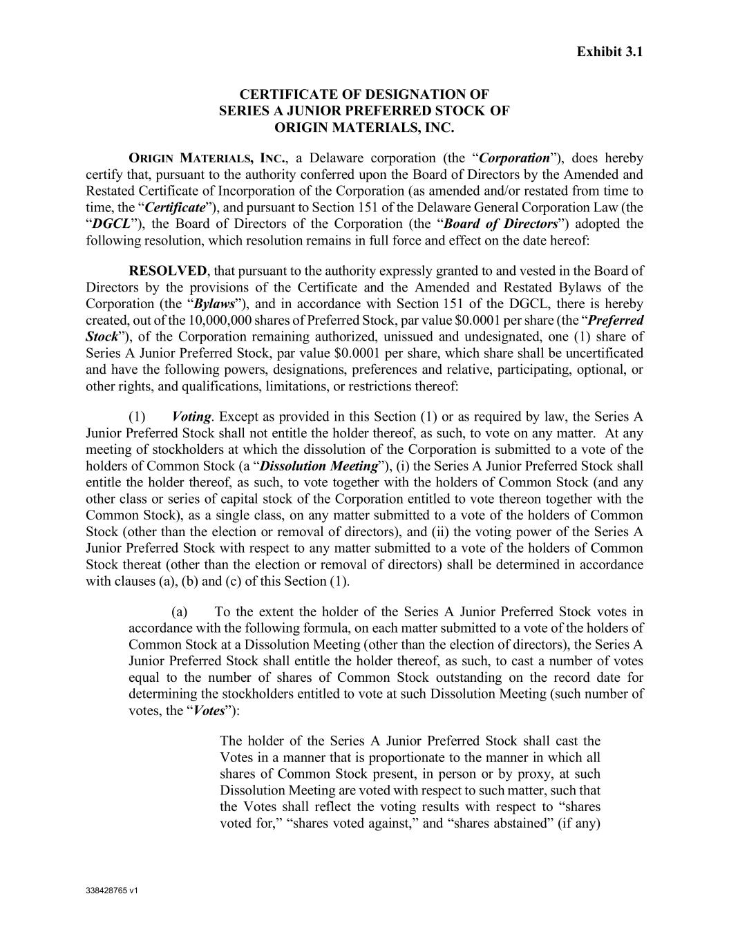

338428765 v1 Exhibit 3.1 CERTIFICATE OF DESIGNATION OF SERIES A JUNIOR PREFERRED STOCK OF ORIGIN MATERIALS, INC. ORIGIN MATERIALS, INC., a Delaware corporation (the “Corporation”), does hereby certify that, pursuant to the authority conferred upon the Board of Directors by the Amended and Restated Certificate of Incorporation of the Corporation (as amended and/or restated from time to time, the “Certificate”), and pursuant to Section 151 of the Delaware General Corporation Law (the “DGCL”), the Board of Directors of the Corporation (the “Board of Directors”) adopted the following resolution, which resolution remains in full force and effect on the date hereof: RESOLVED, that pursuant to the authority expressly granted to and vested in the Board of Directors by the provisions of the Certificate and the Amended and Restated Bylaws of the Corporation (the “Bylaws”), and in accordance with Section 151 of the DGCL, there is hereby created, out of the 10,000,000 shares of Preferred Stock, par value $0.0001 per share (the “Preferred Stock”), of the Corporation remaining authorized, unissued and undesignated, one (1) share of Series A Junior Preferred Stock, par value $0.0001 per share, which share shall be uncertificated and have the following powers, designations, preferences and relative, participating, optional, or other rights, and qualifications, limitations, or restrictions thereof: (1) Voting. Except as provided in this Section (1) or as required by law, the Series A Junior Preferred Stock shall not entitle the holder thereof, as such, to vote on any matter. At any meeting of stockholders at which the dissolution of the Corporation is submitted to a vote of the holders of Common Stock (a “Dissolution Meeting”), (i) the Series A Junior Preferred Stock shall entitle the holder thereof, as such, to vote together with the holders of Common Stock (and any other class or series of capital stock of the Corporation entitled to vote thereon together with the Common Stock), as a single class, on any matter submitted to a vote of the holders of Common Stock (other than the election or removal of directors), and (ii) the voting power of the Series A Junior Preferred Stock with respect to any matter submitted to a vote of the holders of Common Stock thereat (other than the election or removal of directors) shall be determined in accordance with clauses (a), (b) and (c) of this Section (1). (a) To the extent the holder of the Series A Junior Preferred Stock votes in accordance with the following formula, on each matter submitted to a vote of the holders of Common Stock at a Dissolution Meeting (other than the election of directors), the Series A Junior Preferred Stock shall entitle the holder thereof, as such, to cast a number of votes equal to the number of shares of Common Stock outstanding on the record date for determining the stockholders entitled to vote at such Dissolution Meeting (such number of votes, the “Votes”): The holder of the Series A Junior Preferred Stock shall cast the Votes in a manner that is proportionate to the manner in which all shares of Common Stock present, in person or by proxy, at such Dissolution Meeting are voted with respect to such matter, such that the Votes shall reflect the voting results with respect to “shares voted for,” “shares voted against,” and “shares abstained” (if any)

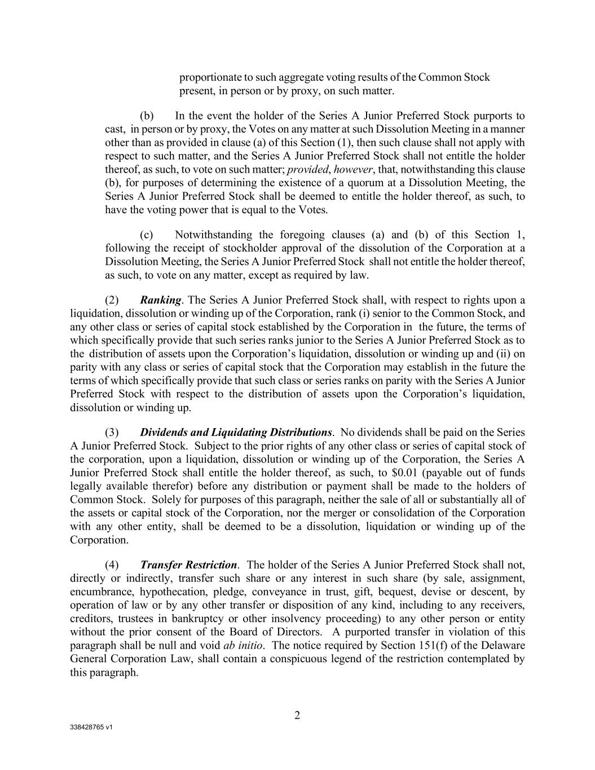
338428765 v1 2 proportionate to such aggregate voting results of the Common Stock present, in person or by proxy, on such matter. (b) In the event the holder of the Series A Junior Preferred Stock purports to cast, in person or by proxy, the Votes on any matter at such Dissolution Meeting in a manner other than as provided in clause (a) of this Section (1), then such clause shall not apply with respect to such matter, and the Series A Junior Preferred Stock shall not entitle the holder thereof, as such, to vote on such matter; provided, however, that, notwithstanding this clause (b), for purposes of determining the existence of a quorum at a Dissolution Meeting, the Series A Junior Preferred Stock shall be deemed to entitle the holder thereof, as such, to have the voting power that is equal to the Votes. (c) Notwithstanding the foregoing clauses (a) and (b) of this Section 1, following the receipt of stockholder approval of the dissolution of the Corporation at a Dissolution Meeting, the Series A Junior Preferred Stock shall not entitle the holder thereof, as such, to vote on any matter, except as required by law. (2) Ranking. The Series A Junior Preferred Stock shall, with respect to rights upon a liquidation, dissolution or winding up of the Corporation, rank (i) senior to the Common Stock, and any other class or series of capital stock established by the Corporation in the future, the terms of which specifically provide that such series ranks junior to the Series A Junior Preferred Stock as to the distribution of assets upon the Corporation’s liquidation, dissolution or winding up and (ii) on parity with any class or series of capital stock that the Corporation may establish in the future the terms of which specifically provide that such class or series ranks on parity with the Series A Junior Preferred Stock with respect to the distribution of assets upon the Corporation’s liquidation, dissolution or winding up. (3) Dividends and Liquidating Distributions. No dividends shall be paid on the Series A Junior Preferred Stock. Subject to the prior rights of any other class or series of capital stock of the corporation, upon a liquidation, dissolution or winding up of the Corporation, the Series A Junior Preferred Stock shall entitle the holder thereof, as such, to $0.01 (payable out of funds legally available therefor) before any distribution or payment shall be made to the holders of Common Stock. Solely for purposes of this paragraph, neither the sale of all or substantially all of the assets or capital stock of the Corporation, nor the merger or consolidation of the Corporation with any other entity, shall be deemed to be a dissolution, liquidation or winding up of the Corporation. (4) Transfer Restriction. The holder of the Series A Junior Preferred Stock shall not, directly or indirectly, transfer such share or any interest in such share (by sale, assignment, encumbrance, hypothecation, pledge, conveyance in trust, gift, bequest, devise or descent, by operation of law or by any other transfer or disposition of any kind, including to any receivers, creditors, trustees in bankruptcy or other insolvency proceeding) to any other person or entity without the prior consent of the Board of Directors. A purported transfer in violation of this paragraph shall be null and void ab initio. The notice required by Section 151(f) of the Delaware General Corporation Law, shall contain a conspicuous legend of the restriction contemplated by this paragraph.


338428765 v1 3 (5) Amendments. In addition to any vote required by law or provided by the Certificate, any amendment to the provisions of this Certificate of Designation shall require the approval of the holder of the Series A Junior Preferred Stock, voting as a separate class. * * * * *

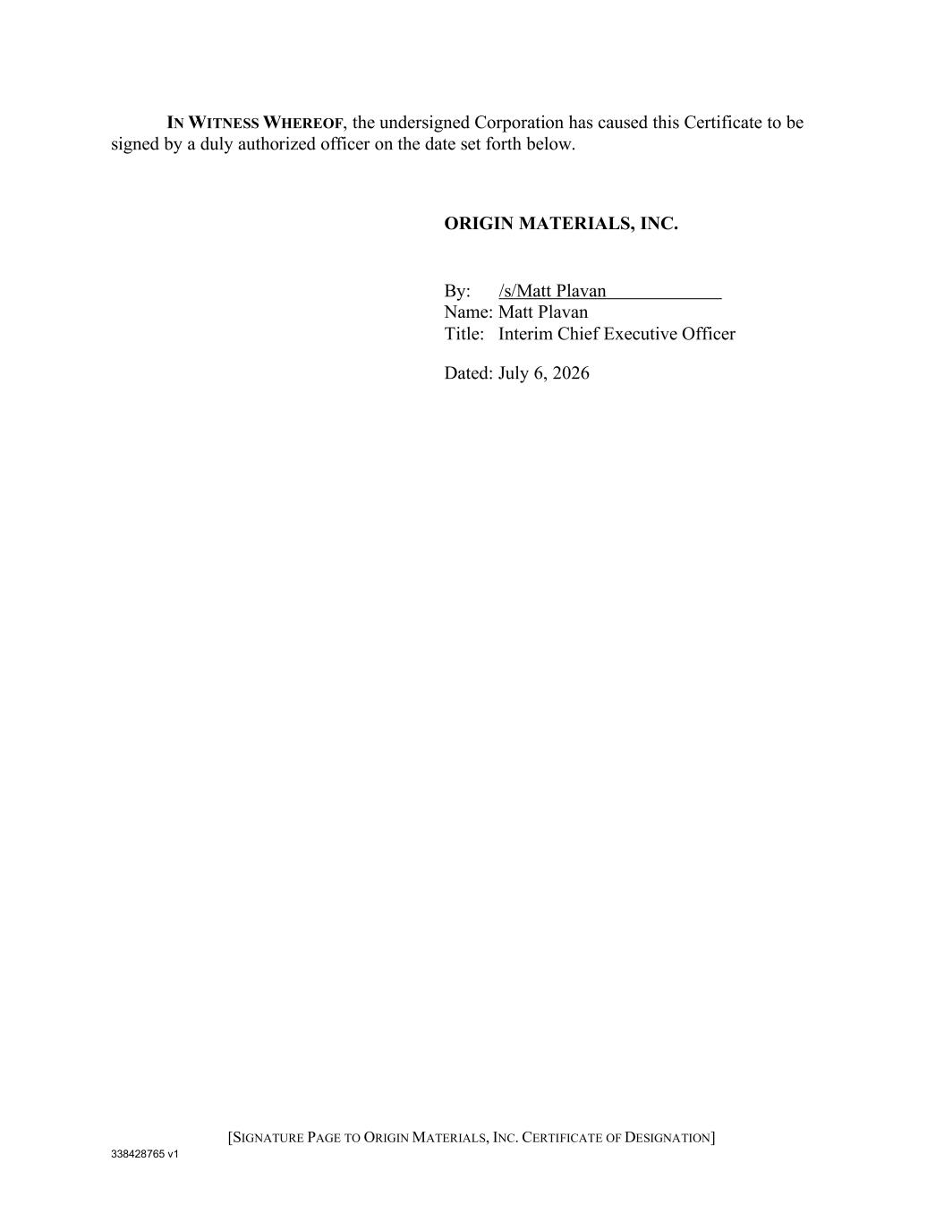
338428765 v1 [SIGNATURE PAGE TO ORIGIN MATERIALS, INC. CERTIFICATE OF DESIGNATION] IN WITNESS WHEREOF, the undersigned Corporation has caused this Certificate to be signed by a duly authorized officer on the date set forth below. ORIGIN MATERIALS, INC. By: /s/Matt Plavan Name: Matt Plavan Title: Interim Chief Executive Officer Dated: July 6, 2026

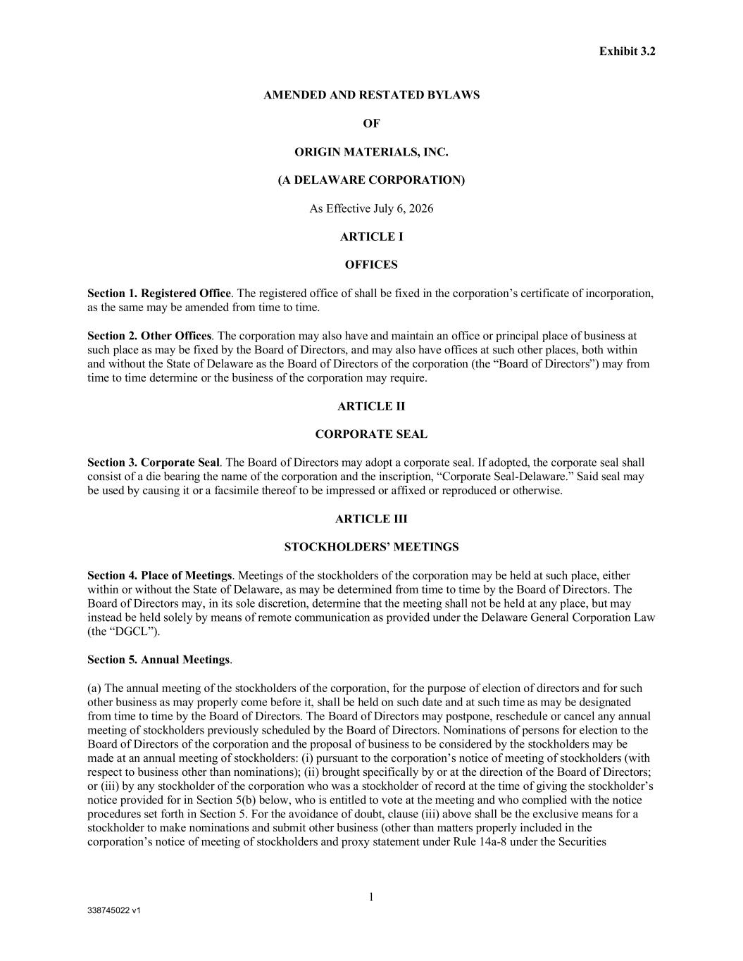
338745022 v1 Exhibit 3.2 1 AMENDED AND RESTATED BYLAWS OF ORIGIN MATERIALS, INC. (A DELAWARE CORPORATION) As Effective July 6, 2026 ARTICLE I OFFICES Section 1. Registered Office. The registered office of shall be fixed in the corporation’s certificate of incorporation, as the same may be amended from time to time. Section 2. Other Offices. The corporation may also have and maintain an office or principal place of business at such place as may be fixed by the Board of Directors, and may also have offices at such other places, both within and without the State of Delaware as the Board of Directors of the corporation (the “Board of Directors”) may from time to time determine or the business of the corporation may require. ARTICLE II CORPORATE SEAL Section 3. Corporate Seal. The Board of Directors may adopt a corporate seal. If adopted, the corporate seal shall consist of a die bearing the name of the corporation and the inscription, “Corporate Seal-Delaware.” Said seal may be used by causing it or a facsimile thereof to be impressed or affixed or reproduced or otherwise. ARTICLE III STOCKHOLDERS’ MEETINGS Section 4. Place of Meetings. Meetings of the stockholders of the corporation may be held at such place, either within or without the State of Delaware, as may be determined from time to time by the Board of Directors. The Board of Directors may, in its sole discretion, determine that the meeting shall not be held at any place, but may instead be held solely by means of remote communication as provided under the Delaware General Corporation Law (the “DGCL”). Section 5. Annual Meetings. (a) The annual meeting of the stockholders of the corporation, for the purpose of election of directors and for such other business as may properly come before it, shall be held on such date and at such time as may be designated from time to time by the Board of Directors. The Board of Directors may postpone, reschedule or cancel any annual meeting of stockholders previously scheduled by the Board of Directors. Nominations of persons for election to the Board of Directors of the corporation and the proposal of business to be considered by the stockholders may be made at an annual meeting of stockholders: (i) pursuant to the corporation’s notice of meeting of stockholders (with respect to business other than nominations); (ii) brought specifically by or at the direction of the Board of Directors; or (iii) by any stockholder of the corporation who was a stockholder of record at the time of giving the stockholder’s notice provided for in Section 5(b) below, who is entitled to vote at the meeting and who complied with the notice procedures set forth in Section 5. For the avoidance of doubt, clause (iii) above shall be the exclusive means for a stockholder to make nominations and submit other business (other than matters properly included in the corporation’s notice of meeting of stockholders and proxy statement under Rule 14a-8 under the Securities

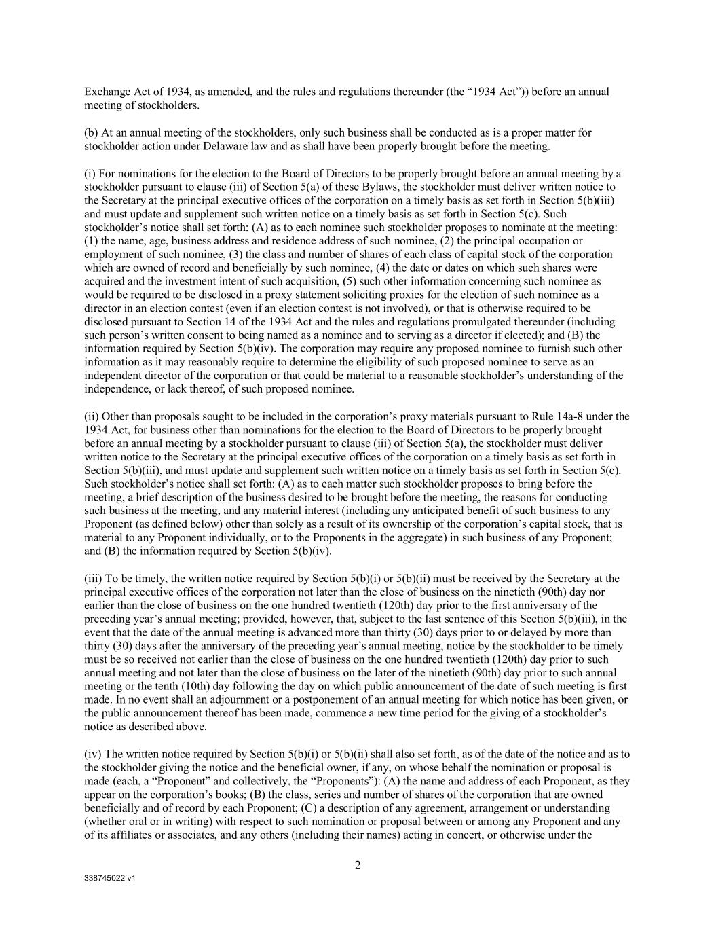
338745022 v1 2 Exchange Act of 1934, as amended, and the rules and regulations thereunder (the “1934 Act”)) before an annual meeting of stockholders. (b) At an annual meeting of the stockholders, only such business shall be conducted as is a proper matter for stockholder action under Delaware law and as shall have been properly brought before the meeting. (i) For nominations for the election to the Board of Directors to be properly brought before an annual meeting by a stockholder pursuant to clause (iii) of Section 5(a) of these Bylaws, the stockholder must deliver written notice to the Secretary at the principal executive offices of the corporation on a timely basis as set forth in Section 5(b)(iii) and must update and supplement such written notice on a timely basis as set forth in Section 5(c). Such stockholder’s notice shall set forth: (A) as to each nominee such stockholder proposes to nominate at the meeting: (1) the name, age, business address and residence address of such nominee, (2) the principal occupation or employment of such nominee, (3) the class and number of shares of each class of capital stock of the corporation which are owned of record and beneficially by such nominee, (4) the date or dates on which such shares were acquired and the investment intent of such acquisition, (5) such other information concerning such nominee as would be required to be disclosed in a proxy statement soliciting proxies for the election of such nominee as a director in an election contest (even if an election contest is not involved), or that is otherwise required to be disclosed pursuant to Section 14 of the 1934 Act and the rules and regulations promulgated thereunder (including such person’s written consent to being named as a nominee and to serving as a director if elected); and (B) the information required by Section 5(b)(iv). The corporation may require any proposed nominee to furnish such other information as it may reasonably require to determine the eligibility of such proposed nominee to serve as an independent director of the corporation or that could be material to a reasonable stockholder’s understanding of the independence, or lack thereof, of such proposed nominee. (ii) Other than proposals sought to be included in the corporation’s proxy materials pursuant to Rule 14a-8 under the 1934 Act, for business other than nominations for the election to the Board of Directors to be properly brought before an annual meeting by a stockholder pursuant to clause (iii) of Section 5(a), the stockholder must deliver written notice to the Secretary at the principal executive offices of the corporation on a timely basis as set forth in Section 5(b)(iii), and must update and supplement such written notice on a timely basis as set forth in Section 5(c). Such stockholder’s notice shall set forth: (A) as to each matter such stockholder proposes to bring before the meeting, a brief description of the business desired to be brought before the meeting, the reasons for conducting such business at the meeting, and any material interest (including any anticipated benefit of such business to any Proponent (as defined below) other than solely as a result of its ownership of the corporation’s capital stock, that is material to any Proponent individually, or to the Proponents in the aggregate) in such business of any Proponent; and (B) the information required by Section 5(b)(iv). (iii) To be timely, the written notice required by Section 5(b)(i) or 5(b)(ii) must be received by the Secretary at the principal executive offices of the corporation not later than the close of business on the ninetieth (90th) day nor earlier than the close of business on the one hundred twentieth (120th) day prior to the first anniversary of the preceding year’s annual meeting; provided, however, that, subject to the last sentence of this Section 5(b)(iii), in the event that the date of the annual meeting is advanced more than thirty (30) days prior to or delayed by more than thirty (30) days after the anniversary of the preceding year’s annual meeting, notice by the stockholder to be timely must be so received not earlier than the close of business on the one hundred twentieth (120th) day prior to such annual meeting and not later than the close of business on the later of the ninetieth (90th) day prior to such annual meeting or the tenth (10th) day following the day on which public announcement of the date of such meeting is first made. In no event shall an adjournment or a postponement of an annual meeting for which notice has been given, or the public announcement thereof has been made, commence a new time period for the giving of a stockholder’s notice as described above. (iv) The written notice required by Section 5(b)(i) or 5(b)(ii) shall also set forth, as of the date of the notice and as to the stockholder giving the notice and the beneficial owner, if any, on whose behalf the nomination or proposal is made (each, a “Proponent” and collectively, the “Proponents”): (A) the name and address of each Proponent, as they appear on the corporation’s books; (B) the class, series and number of shares of the corporation that are owned beneficially and of record by each Proponent; (C) a description of any agreement, arrangement or understanding (whether oral or in writing) with respect to such nomination or proposal between or among any Proponent and any of its affiliates or associates, and any others (including their names) acting in concert, or otherwise under the

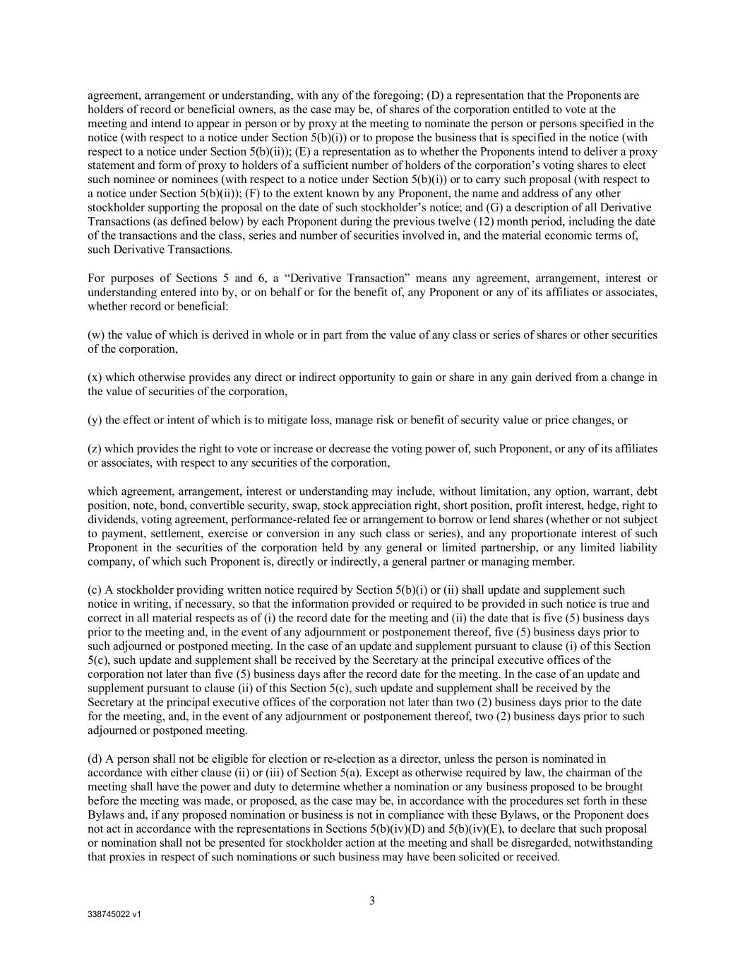
338745022 v1 3 agreement, arrangement or understanding, with any of the foregoing; (D) a representation that the Proponents are holders of record or beneficial owners, as the case may be, of shares of the corporation entitled to vote at the meeting and intend to appear in person or by proxy at the meeting to nominate the person or persons specified in the notice (with respect to a notice under Section 5(b)(i)) or to propose the business that is specified in the notice (with respect to a notice under Section 5(b)(ii)); (E) a representation as to whether the Proponents intend to deliver a proxy statement and form of proxy to holders of a sufficient number of holders of the corporation’s voting shares to elect such nominee or nominees (with respect to a notice under Section 5(b)(i)) or to carry such proposal (with respect to a notice under Section 5(b)(ii)); (F) to the extent known by any Proponent, the name and address of any other stockholder supporting the proposal on the date of such stockholder’s notice; and (G) a description of all Derivative Transactions (as defined below) by each Proponent during the previous twelve (12) month period, including the date of the transactions and the class, series and number of securities involved in, and the material economic terms of, such Derivative Transactions. For purposes of Sections 5 and 6, a “Derivative Transaction” means any agreement, arrangement, interest or understanding entered into by, or on behalf or for the benefit of, any Proponent or any of its affiliates or associates, whether record or beneficial: (w) the value of which is derived in whole or in part from the value of any class or series of shares or other securities of the corporation, (x) which otherwise provides any direct or indirect opportunity to gain or share in any gain derived from a change in the value of securities of the corporation, (y) the effect or intent of which is to mitigate loss, manage risk or benefit of security value or price changes, or (z) which provides the right to vote or increase or decrease the voting power of, such Proponent, or any of its affiliates or associates, with respect to any securities of the corporation, which agreement, arrangement, interest or understanding may include, without limitation, any option, warrant, debt position, note, bond, convertible security, swap, stock appreciation right, short position, profit interest, hedge, right to dividends, voting agreement, performance-related fee or arrangement to borrow or lend shares (whether or not subject to payment, settlement, exercise or conversion in any such class or series), and any proportionate interest of such Proponent in the securities of the corporation held by any general or limited partnership, or any limited liability company, of which such Proponent is, directly or indirectly, a general partner or managing member. (c) A stockholder providing written notice required by Section 5(b)(i) or (ii) shall update and supplement such notice in writing, if necessary, so that the information provided or required to be provided in such notice is true and correct in all material respects as of (i) the record date for the meeting and (ii) the date that is five (5) business days prior to the meeting and, in the event of any adjournment or postponement thereof, five (5) business days prior to such adjourned or postponed meeting. In the case of an update and supplement pursuant to clause (i) of this Section 5(c), such update and supplement shall be received by the Secretary at the principal executive offices of the corporation not later than five (5) business days after the record date for the meeting. In the case of an update and supplement pursuant to clause (ii) of this Section 5(c), such update and supplement shall be received by the Secretary at the principal executive offices of the corporation not later than two (2) business days prior to the date for the meeting, and, in the event of any adjournment or postponement thereof, two (2) business days prior to such adjourned or postponed meeting. (d) A person shall not be eligible for election or re-election as a director, unless the person is nominated in accordance with either clause (ii) or (iii) of Section 5(a). Except as otherwise required by law, the chairman of the meeting shall have the power and duty to determine whether a nomination or any business proposed to be brought before the meeting was made, or proposed, as the case may be, in accordance with the procedures set forth in these Bylaws and, if any proposed nomination or business is not in compliance with these Bylaws, or the Proponent does not act in accordance with the representations in Sections 5(b)(iv)(D) and 5(b)(iv)(E), to declare that such proposal or nomination shall not be presented for stockholder action at the meeting and shall be disregarded, notwithstanding that proxies in respect of such nominations or such business may have been solicited or received.

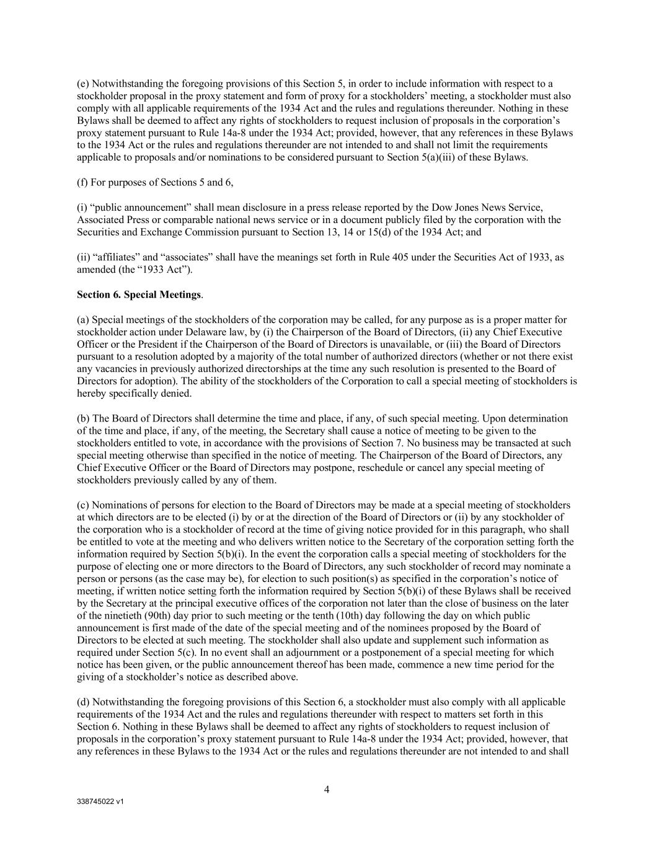
338745022 v1 4 (e) Notwithstanding the foregoing provisions of this Section 5, in order to include information with respect to a stockholder proposal in the proxy statement and form of proxy for a stockholders’ meeting, a stockholder must also comply with all applicable requirements of the 1934 Act and the rules and regulations thereunder. Nothing in these Bylaws shall be deemed to affect any rights of stockholders to request inclusion of proposals in the corporation’s proxy statement pursuant to Rule 14a-8 under the 1934 Act; provided, however, that any references in these Bylaws to the 1934 Act or the rules and regulations thereunder are not intended to and shall not limit the requirements applicable to proposals and/or nominations to be considered pursuant to Section 5(a)(iii) of these Bylaws. (f) For purposes of Sections 5 and 6, (i) “public announcement” shall mean disclosure in a press release reported by the Dow Jones News Service, Associated Press or comparable national news service or in a document publicly filed by the corporation with the Securities and Exchange Commission pursuant to Section 13, 14 or 15(d) of the 1934 Act; and (ii) “affiliates” and “associates” shall have the meanings set forth in Rule 405 under the Securities Act of 1933, as amended (the “1933 Act”). Section 6. Special Meetings. (a) Special meetings of the stockholders of the corporation may be called, for any purpose as is a proper matter for stockholder action under Delaware law, by (i) the Chairperson of the Board of Directors, (ii) any Chief Executive Officer or the President if the Chairperson of the Board of Directors is unavailable, or (iii) the Board of Directors pursuant to a resolution adopted by a majority of the total number of authorized directors (whether or not there exist any vacancies in previously authorized directorships at the time any such resolution is presented to the Board of Directors for adoption). The ability of the stockholders of the Corporation to call a special meeting of stockholders is hereby specifically denied. (b) The Board of Directors shall determine the time and place, if any, of such special meeting. Upon determination of the time and place, if any, of the meeting, the Secretary shall cause a notice of meeting to be given to the stockholders entitled to vote, in accordance with the provisions of Section 7. No business may be transacted at such special meeting otherwise than specified in the notice of meeting. The Chairperson of the Board of Directors, any Chief Executive Officer or the Board of Directors may postpone, reschedule or cancel any special meeting of stockholders previously called by any of them. (c) Nominations of persons for election to the Board of Directors may be made at a special meeting of stockholders at which directors are to be elected (i) by or at the direction of the Board of Directors or (ii) by any stockholder of the corporation who is a stockholder of record at the time of giving notice provided for in this paragraph, who shall be entitled to vote at the meeting and who delivers written notice to the Secretary of the corporation setting forth the information required by Section 5(b)(i). In the event the corporation calls a special meeting of stockholders for the purpose of electing one or more directors to the Board of Directors, any such stockholder of record may nominate a person or persons (as the case may be), for election to such position(s) as specified in the corporation’s notice of meeting, if written notice setting forth the information required by Section 5(b)(i) of these Bylaws shall be received by the Secretary at the principal executive offices of the corporation not later than the close of business on the later of the ninetieth (90th) day prior to such meeting or the tenth (10th) day following the day on which public announcement is first made of the date of the special meeting and of the nominees proposed by the Board of Directors to be elected at such meeting. The stockholder shall also update and supplement such information as required under Section 5(c). In no event shall an adjournment or a postponement of a special meeting for which notice has been given, or the public announcement thereof has been made, commence a new time period for the giving of a stockholder’s notice as described above. (d) Notwithstanding the foregoing provisions of this Section 6, a stockholder must also comply with all applicable requirements of the 1934 Act and the rules and regulations thereunder with respect to matters set forth in this Section 6. Nothing in these Bylaws shall be deemed to affect any rights of stockholders to request inclusion of proposals in the corporation’s proxy statement pursuant to Rule 14a-8 under the 1934 Act; provided, however, that any references in these Bylaws to the 1934 Act or the rules and regulations thereunder are not intended to and shall

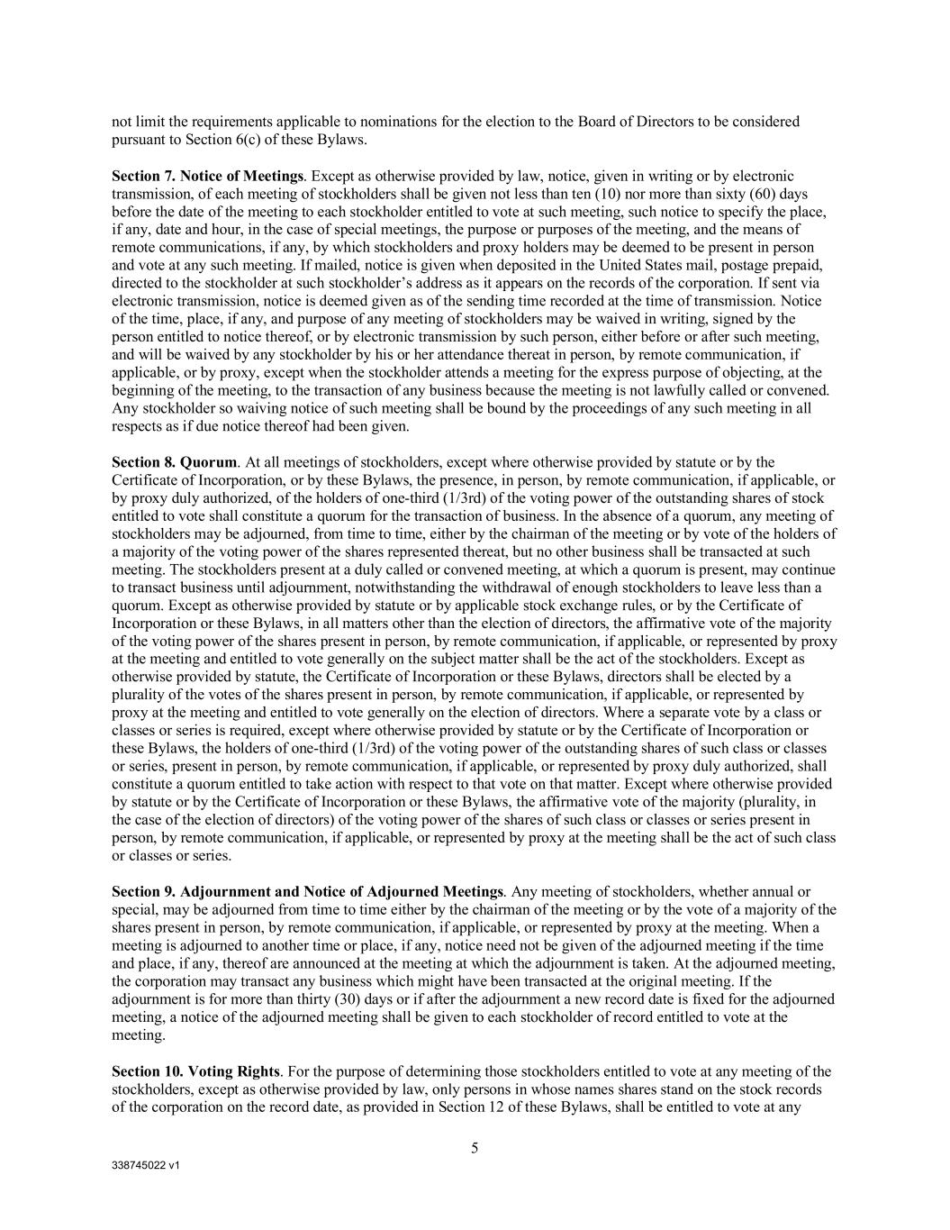
338745022 v1 5 not limit the requirements applicable to nominations for the election to the Board of Directors to be considered pursuant to Section 6(c) of these Bylaws. Section 7. Notice of Meetings. Except as otherwise provided by law, notice, given in writing or by electronic transmission, of each meeting of stockholders shall be given not less than ten (10) nor more than sixty (60) days before the date of the meeting to each stockholder entitled to vote at such meeting, such notice to specify the place, if any, date and hour, in the case of special meetings, the purpose or purposes of the meeting, and the means of remote communications, if any, by which stockholders and proxy holders may be deemed to be present in person and vote at any such meeting. If mailed, notice is given when deposited in the United States mail, postage prepaid, directed to the stockholder at such stockholder’s address as it appears on the records of the corporation. If sent via electronic transmission, notice is deemed given as of the sending time recorded at the time of transmission. Notice of the time, place, if any, and purpose of any meeting of stockholders may be waived in writing, signed by the person entitled to notice thereof, or by electronic transmission by such person, either before or after such meeting, and will be waived by any stockholder by his or her attendance thereat in person, by remote communication, if applicable, or by proxy, except when the stockholder attends a meeting for the express purpose of objecting, at the beginning of the meeting, to the transaction of any business because the meeting is not lawfully called or convened. Any stockholder so waiving notice of such meeting shall be bound by the proceedings of any such meeting in all respects as if due notice thereof had been given. Section 8. Quorum. At all meetings of stockholders, except where otherwise provided by statute or by the Certificate of Incorporation, or by these Bylaws, the presence, in person, by remote communication, if applicable, or by proxy duly authorized, of the holders of one-third (1/3rd) of the voting power of the outstanding shares of stock entitled to vote shall constitute a quorum for the transaction of business. In the absence of a quorum, any meeting of stockholders may be adjourned, from time to time, either by the chairman of the meeting or by vote of the holders of a majority of the voting power of the shares represented thereat, but no other business shall be transacted at such meeting. The stockholders present at a duly called or convened meeting, at which a quorum is present, may continue to transact business until adjournment, notwithstanding the withdrawal of enough stockholders to leave less than a quorum. Except as otherwise provided by statute or by applicable stock exchange rules, or by the Certificate of Incorporation or these Bylaws, in all matters other than the election of directors, the affirmative vote of the majority of the voting power of the shares present in person, by remote communication, if applicable, or represented by proxy at the meeting and entitled to vote generally on the subject matter shall be the act of the stockholders. Except as otherwise provided by statute, the Certificate of Incorporation or these Bylaws, directors shall be elected by a plurality of the votes of the shares present in person, by remote communication, if applicable, or represented by proxy at the meeting and entitled to vote generally on the election of directors. Where a separate vote by a class or classes or series is required, except where otherwise provided by statute or by the Certificate of Incorporation or these Bylaws, the holders of one-third (1/3rd) of the voting power of the outstanding shares of such class or classes or series, present in person, by remote communication, if applicable, or represented by proxy duly authorized, shall constitute a quorum entitled to take action with respect to that vote on that matter. Except where otherwise provided by statute or by the Certificate of Incorporation or these Bylaws, the affirmative vote of the majority (plurality, in the case of the election of directors) of the voting power of the shares of such class or classes or series present in person, by remote communication, if applicable, or represented by proxy at the meeting shall be the act of such class or classes or series. Section 9. Adjournment and Notice of Adjourned Meetings. Any meeting of stockholders, whether annual or special, may be adjourned from time to time either by the chairman of the meeting or by the vote of a majority of the shares present in person, by remote communication, if applicable, or represented by proxy at the meeting. When a meeting is adjourned to another time or place, if any, notice need not be given of the adjourned meeting if the time and place, if any, thereof are announced at the meeting at which the adjournment is taken. At the adjourned meeting, the corporation may transact any business which might have been transacted at the original meeting. If the adjournment is for more than thirty (30) days or if after the adjournment a new record date is fixed for the adjourned meeting, a notice of the adjourned meeting shall be given to each stockholder of record entitled to vote at the meeting. Section 10. Voting Rights. For the purpose of determining those stockholders entitled to vote at any meeting of the stockholders, except as otherwise provided by law, only persons in whose names shares stand on the stock records of the corporation on the record date, as provided in Section 12 of these Bylaws, shall be entitled to vote at any

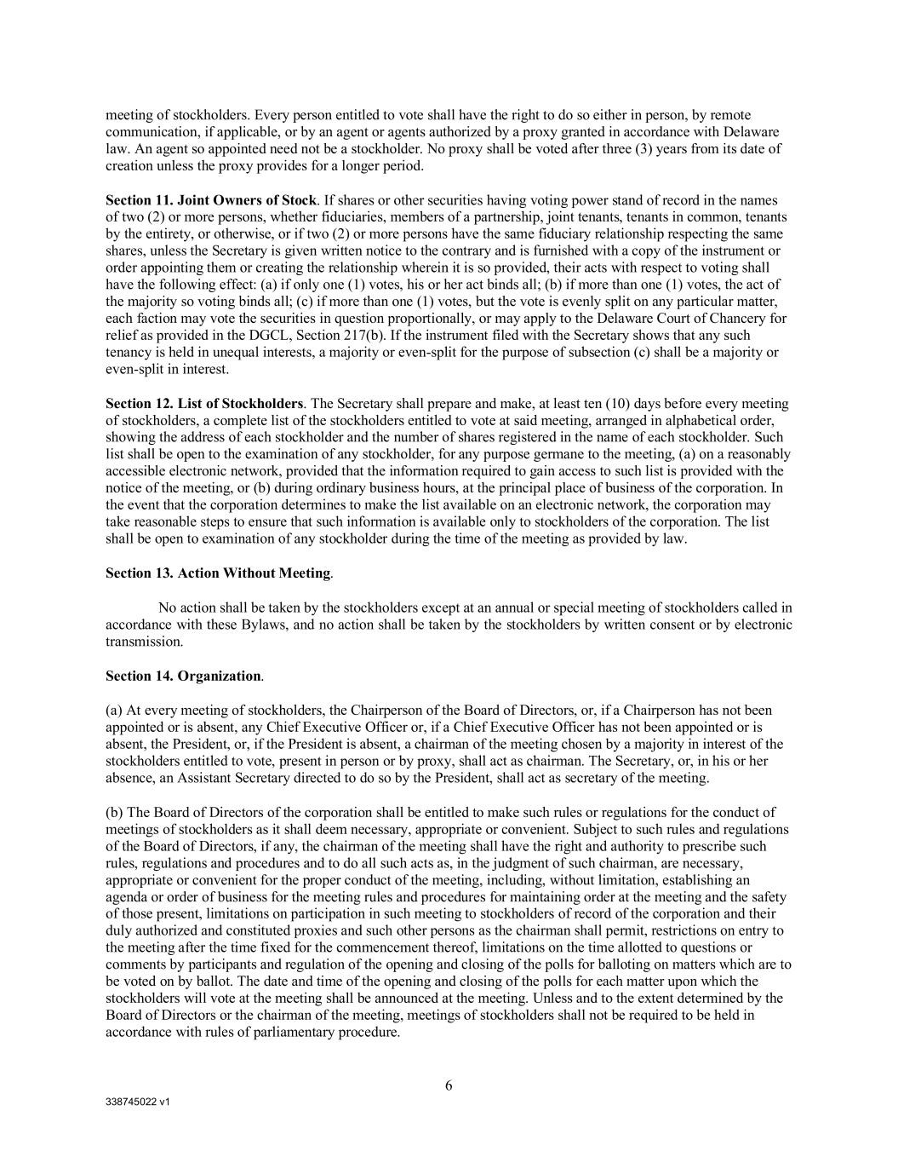
338745022 v1 6 meeting of stockholders. Every person entitled to vote shall have the right to do so either in person, by remote communication, if applicable, or by an agent or agents authorized by a proxy granted in accordance with Delaware law. An agent so appointed need not be a stockholder. No proxy shall be voted after three (3) years from its date of creation unless the proxy provides for a longer period. Section 11. Joint Owners of Stock. If shares or other securities having voting power stand of record in the names of two (2) or more persons, whether fiduciaries, members of a partnership, joint tenants, tenants in common, tenants by the entirety, or otherwise, or if two (2) or more persons have the same fiduciary relationship respecting the same shares, unless the Secretary is given written notice to the contrary and is furnished with a copy of the instrument or order appointing them or creating the relationship wherein it is so provided, their acts with respect to voting shall have the following effect: (a) if only one (1) votes, his or her act binds all; (b) if more than one (1) votes, the act of the majority so voting binds all; (c) if more than one (1) votes, but the vote is evenly split on any particular matter, each faction may vote the securities in question proportionally, or may apply to the Delaware Court of Chancery for relief as provided in the DGCL, Section 217(b). If the instrument filed with the Secretary shows that any such tenancy is held in unequal interests, a majority or even-split for the purpose of subsection (c) shall be a majority or even-split in interest. Section 12. List of Stockholders. The Secretary shall prepare and make, at least ten (10) days before every meeting of stockholders, a complete list of the stockholders entitled to vote at said meeting, arranged in alphabetical order, showing the address of each stockholder and the number of shares registered in the name of each stockholder. Such list shall be open to the examination of any stockholder, for any purpose germane to the meeting, (a) on a reasonably accessible electronic network, provided that the information required to gain access to such list is provided with the notice of the meeting, or (b) during ordinary business hours, at the principal place of business of the corporation. In the event that the corporation determines to make the list available on an electronic network, the corporation may take reasonable steps to ensure that such information is available only to stockholders of the corporation. The list shall be open to examination of any stockholder during the time of the meeting as provided by law. Section 13. Action Without Meeting. No action shall be taken by the stockholders except at an annual or special meeting of stockholders called in accordance with these Bylaws, and no action shall be taken by the stockholders by written consent or by electronic transmission. Section 14. Organization. (a) At every meeting of stockholders, the Chairperson of the Board of Directors, or, if a Chairperson has not been appointed or is absent, any Chief Executive Officer or, if a Chief Executive Officer has not been appointed or is absent, the President, or, if the President is absent, a chairman of the meeting chosen by a majority in interest of the stockholders entitled to vote, present in person or by proxy, shall act as chairman. The Secretary, or, in his or her absence, an Assistant Secretary directed to do so by the President, shall act as secretary of the meeting. (b) The Board of Directors of the corporation shall be entitled to make such rules or regulations for the conduct of meetings of stockholders as it shall deem necessary, appropriate or convenient. Subject to such rules and regulations of the Board of Directors, if any, the chairman of the meeting shall have the right and authority to prescribe such rules, regulations and procedures and to do all such acts as, in the judgment of such chairman, are necessary, appropriate or convenient for the proper conduct of the meeting, including, without limitation, establishing an agenda or order of business for the meeting rules and procedures for maintaining order at the meeting and the safety of those present, limitations on participation in such meeting to stockholders of record of the corporation and their duly authorized and constituted proxies and such other persons as the chairman shall permit, restrictions on entry to the meeting after the time fixed for the commencement thereof, limitations on the time allotted to questions or comments by participants and regulation of the opening and closing of the polls for balloting on matters which are to be voted on by ballot. The date and time of the opening and closing of the polls for each matter upon which the stockholders will vote at the meeting shall be announced at the meeting. Unless and to the extent determined by the Board of Directors or the chairman of the meeting, meetings of stockholders shall not be required to be held in accordance with rules of parliamentary procedure.

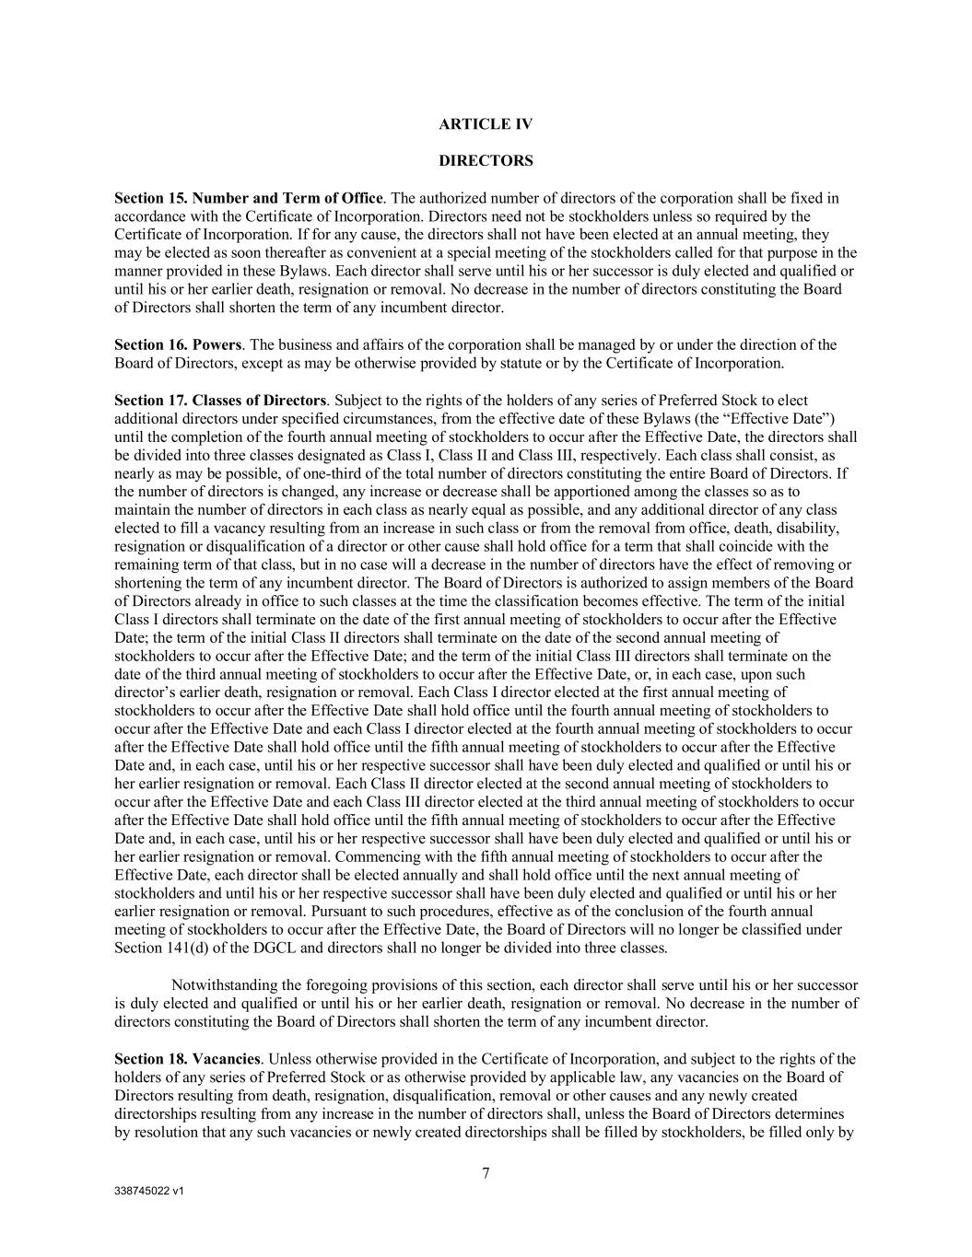
338745022 v1 7 ARTICLE IV DIRECTORS Section 15. Number and Term of Office. The authorized number of directors of the corporation shall be fixed in accordance with the Certificate of Incorporation. Directors need not be stockholders unless so required by the Certificate of Incorporation. If for any cause, the directors shall not have been elected at an annual meeting, they may be elected as soon thereafter as convenient at a special meeting of the stockholders called for that purpose in the manner provided in these Bylaws. Each director shall serve until his or her successor is duly elected and qualified or until his or her earlier death, resignation or removal. No decrease in the number of directors constituting the Board of Directors shall shorten the term of any incumbent director. Section 16. Powers. The business and affairs of the corporation shall be managed by or under the direction of the Board of Directors, except as may be otherwise provided by statute or by the Certificate of Incorporation. Section 17. Classes of Directors. Subject to the rights of the holders of any series of Preferred Stock to elect additional directors under specified circumstances, from the effective date of these Bylaws (the “Effective Date”) until the completion of the fourth annual meeting of stockholders to occur after the Effective Date, the directors shall be divided into three classes designated as Class I, Class II and Class III, respectively. Each class shall consist, as nearly as may be possible, of one-third of the total number of directors constituting the entire Board of Directors. If the number of directors is changed, any increase or decrease shall be apportioned among the classes so as to maintain the number of directors in each class as nearly equal as possible, and any additional director of any class elected to fill a vacancy resulting from an increase in such class or from the removal from office, death, disability, resignation or disqualification of a director or other cause shall hold office for a term that shall coincide with the remaining term of that class, but in no case will a decrease in the number of directors have the effect of removing or shortening the term of any incumbent director. The Board of Directors is authorized to assign members of the Board of Directors already in office to such classes at the time the classification becomes effective. The term of the initial Class I directors shall terminate on the date of the first annual meeting of stockholders to occur after the Effective Date; the term of the initial Class II directors shall terminate on the date of the second annual meeting of stockholders to occur after the Effective Date; and the term of the initial Class III directors shall terminate on the date of the third annual meeting of stockholders to occur after the Effective Date, or, in each case, upon such director’s earlier death, resignation or removal. Each Class I director elected at the first annual meeting of stockholders to occur after the Effective Date shall hold office until the fourth annual meeting of stockholders to occur after the Effective Date and each Class I director elected at the fourth annual meeting of stockholders to occur after the Effective Date shall hold office until the fifth annual meeting of stockholders to occur after the Effective Date and, in each case, until his or her respective successor shall have been duly elected and qualified or until his or her earlier resignation or removal. Each Class II director elected at the second annual meeting of stockholders to occur after the Effective Date and each Class III director elected at the third annual meeting of stockholders to occur after the Effective Date shall hold office until the fifth annual meeting of stockholders to occur after the Effective Date and, in each case, until his or her respective successor shall have been duly elected and qualified or until his or her earlier resignation or removal. Commencing with the fifth annual meeting of stockholders to occur after the Effective Date, each director shall be elected annually and shall hold office until the next annual meeting of stockholders and until his or her respective successor shall have been duly elected and qualified or until his or her earlier resignation or removal. Pursuant to such procedures, effective as of the conclusion of the fourth annual meeting of stockholders to occur after the Effective Date, the Board of Directors will no longer be classified under Section 141(d) of the DGCL and directors shall no longer be divided into three classes. Notwithstanding the foregoing provisions of this section, each director shall serve until his or her successor is duly elected and qualified or until his or her earlier death, resignation or removal. No decrease in the number of directors constituting the Board of Directors shall shorten the term of any incumbent director. Section 18. Vacancies. Unless otherwise provided in the Certificate of Incorporation, and subject to the rights of the holders of any series of Preferred Stock or as otherwise provided by applicable law, any vacancies on the Board of Directors resulting from death, resignation, disqualification, removal or other causes and any newly created directorships resulting from any increase in the number of directors shall, unless the Board of Directors determines by resolution that any such vacancies or newly created directorships shall be filled by stockholders, be filled only by

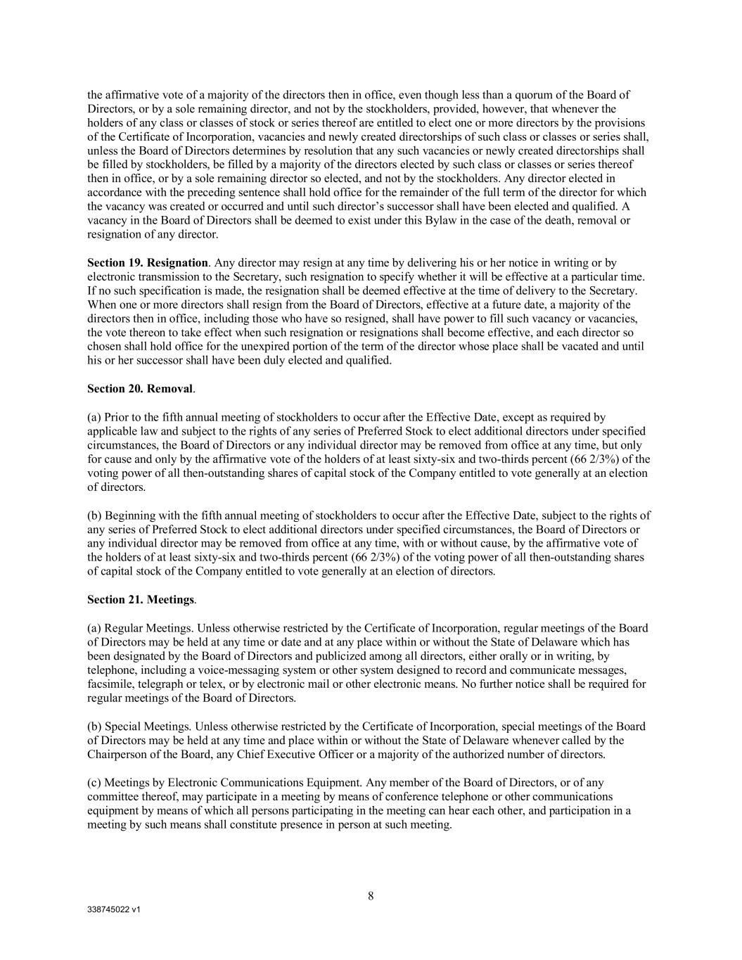
338745022 v1 8 the affirmative vote of a majority of the directors then in office, even though less than a quorum of the Board of Directors, or by a sole remaining director, and not by the stockholders, provided, however, that whenever the holders of any class or classes of stock or series thereof are entitled to elect one or more directors by the provisions of the Certificate of Incorporation, vacancies and newly created directorships of such class or classes or series shall, unless the Board of Directors determines by resolution that any such vacancies or newly created directorships shall be filled by stockholders, be filled by a majority of the directors elected by such class or classes or series thereof then in office, or by a sole remaining director so elected, and not by the stockholders. Any director elected in accordance with the preceding sentence shall hold office for the remainder of the full term of the director for which the vacancy was created or occurred and until such director’s successor shall have been elected and qualified. A vacancy in the Board of Directors shall be deemed to exist under this Bylaw in the case of the death, removal or resignation of any director. Section 19. Resignation. Any director may resign at any time by delivering his or her notice in writing or by electronic transmission to the Secretary, such resignation to specify whether it will be effective at a particular time. If no such specification is made, the resignation shall be deemed effective at the time of delivery to the Secretary. When one or more directors shall resign from the Board of Directors, effective at a future date, a majority of the directors then in office, including those who have so resigned, shall have power to fill such vacancy or vacancies, the vote thereon to take effect when such resignation or resignations shall become effective, and each director so chosen shall hold office for the unexpired portion of the term of the director whose place shall be vacated and until his or her successor shall have been duly elected and qualified. Section 20. Removal. (a) Prior to the fifth annual meeting of stockholders to occur after the Effective Date, except as required by applicable law and subject to the rights of any series of Preferred Stock to elect additional directors under specified circumstances, the Board of Directors or any individual director may be removed from office at any time, but only for cause and only by the affirmative vote of the holders of at least sixty-six and two-thirds percent (66 2/3%) of the voting power of all then-outstanding shares of capital stock of the Company entitled to vote generally at an election of directors. (b) Beginning with the fifth annual meeting of stockholders to occur after the Effective Date, subject to the rights of any series of Preferred Stock to elect additional directors under specified circumstances, the Board of Directors or any individual director may be removed from office at any time, with or without cause, by the affirmative vote of the holders of at least sixty-six and two-thirds percent (66 2/3%) of the voting power of all then-outstanding shares of capital stock of the Company entitled to vote generally at an election of directors. Section 21. Meetings. (a) Regular Meetings. Unless otherwise restricted by the Certificate of Incorporation, regular meetings of the Board of Directors may be held at any time or date and at any place within or without the State of Delaware which has been designated by the Board of Directors and publicized among all directors, either orally or in writing, by telephone, including a voice-messaging system or other system designed to record and communicate messages, facsimile, telegraph or telex, or by electronic mail or other electronic means. No further notice shall be required for regular meetings of the Board of Directors. (b) Special Meetings. Unless otherwise restricted by the Certificate of Incorporation, special meetings of the Board of Directors may be held at any time and place within or without the State of Delaware whenever called by the Chairperson of the Board, any Chief Executive Officer or a majority of the authorized number of directors. (c) Meetings by Electronic Communications Equipment. Any member of the Board of Directors, or of any committee thereof, may participate in a meeting by means of conference telephone or other communications equipment by means of which all persons participating in the meeting can hear each other, and participation in a meeting by such means shall constitute presence in person at such meeting.

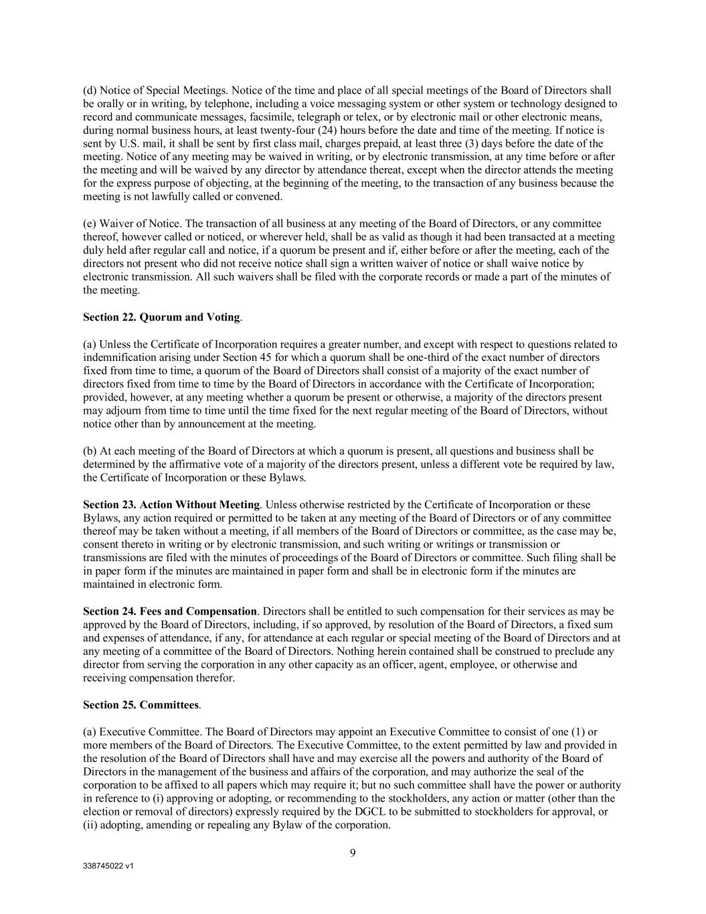
338745022 v1 9 (d) Notice of Special Meetings. Notice of the time and place of all special meetings of the Board of Directors shall be orally or in writing, by telephone, including a voice messaging system or other system or technology designed to record and communicate messages, facsimile, telegraph or telex, or by electronic mail or other electronic means, during normal business hours, at least twenty-four (24) hours before the date and time of the meeting. If notice is sent by U.S. mail, it shall be sent by first class mail, charges prepaid, at least three (3) days before the date of the meeting. Notice of any meeting may be waived in writing, or by electronic transmission, at any time before or after the meeting and will be waived by any director by attendance thereat, except when the director attends the meeting for the express purpose of objecting, at the beginning of the meeting, to the transaction of any business because the meeting is not lawfully called or convened. (e) Waiver of Notice. The transaction of all business at any meeting of the Board of Directors, or any committee thereof, however called or noticed, or wherever held, shall be as valid as though it had been transacted at a meeting duly held after regular call and notice, if a quorum be present and if, either before or after the meeting, each of the directors not present who did not receive notice shall sign a written waiver of notice or shall waive notice by electronic transmission. All such waivers shall be filed with the corporate records or made a part of the minutes of the meeting. Section 22. Quorum and Voting. (a) Unless the Certificate of Incorporation requires a greater number, and except with respect to questions related to indemnification arising under Section 45 for which a quorum shall be one-third of the exact number of directors fixed from time to time, a quorum of the Board of Directors shall consist of a majority of the exact number of directors fixed from time to time by the Board of Directors in accordance with the Certificate of Incorporation; provided, however, at any meeting whether a quorum be present or otherwise, a majority of the directors present may adjourn from time to time until the time fixed for the next regular meeting of the Board of Directors, without notice other than by announcement at the meeting. (b) At each meeting of the Board of Directors at which a quorum is present, all questions and business shall be determined by the affirmative vote of a majority of the directors present, unless a different vote be required by law, the Certificate of Incorporation or these Bylaws. Section 23. Action Without Meeting. Unless otherwise restricted by the Certificate of Incorporation or these Bylaws, any action required or permitted to be taken at any meeting of the Board of Directors or of any committee thereof may be taken without a meeting, if all members of the Board of Directors or committee, as the case may be, consent thereto in writing or by electronic transmission, and such writing or writings or transmission or transmissions are filed with the minutes of proceedings of the Board of Directors or committee. Such filing shall be in paper form if the minutes are maintained in paper form and shall be in electronic form if the minutes are maintained in electronic form. Section 24. Fees and Compensation. Directors shall be entitled to such compensation for their services as may be approved by the Board of Directors, including, if so approved, by resolution of the Board of Directors, a fixed sum and expenses of attendance, if any, for attendance at each regular or special meeting of the Board of Directors and at any meeting of a committee of the Board of Directors. Nothing herein contained shall be construed to preclude any director from serving the corporation in any other capacity as an officer, agent, employee, or otherwise and receiving compensation therefor. Section 25. Committees. (a) Executive Committee. The Board of Directors may appoint an Executive Committee to consist of one (1) or more members of the Board of Directors. The Executive Committee, to the extent permitted by law and provided in the resolution of the Board of Directors shall have and may exercise all the powers and authority of the Board of Directors in the management of the business and affairs of the corporation, and may authorize the seal of the corporation to be affixed to all papers which may require it; but no such committee shall have the power or authority in reference to (i) approving or adopting, or recommending to the stockholders, any action or matter (other than the election or removal of directors) expressly required by the DGCL to be submitted to stockholders for approval, or (ii) adopting, amending or repealing any Bylaw of the corporation.

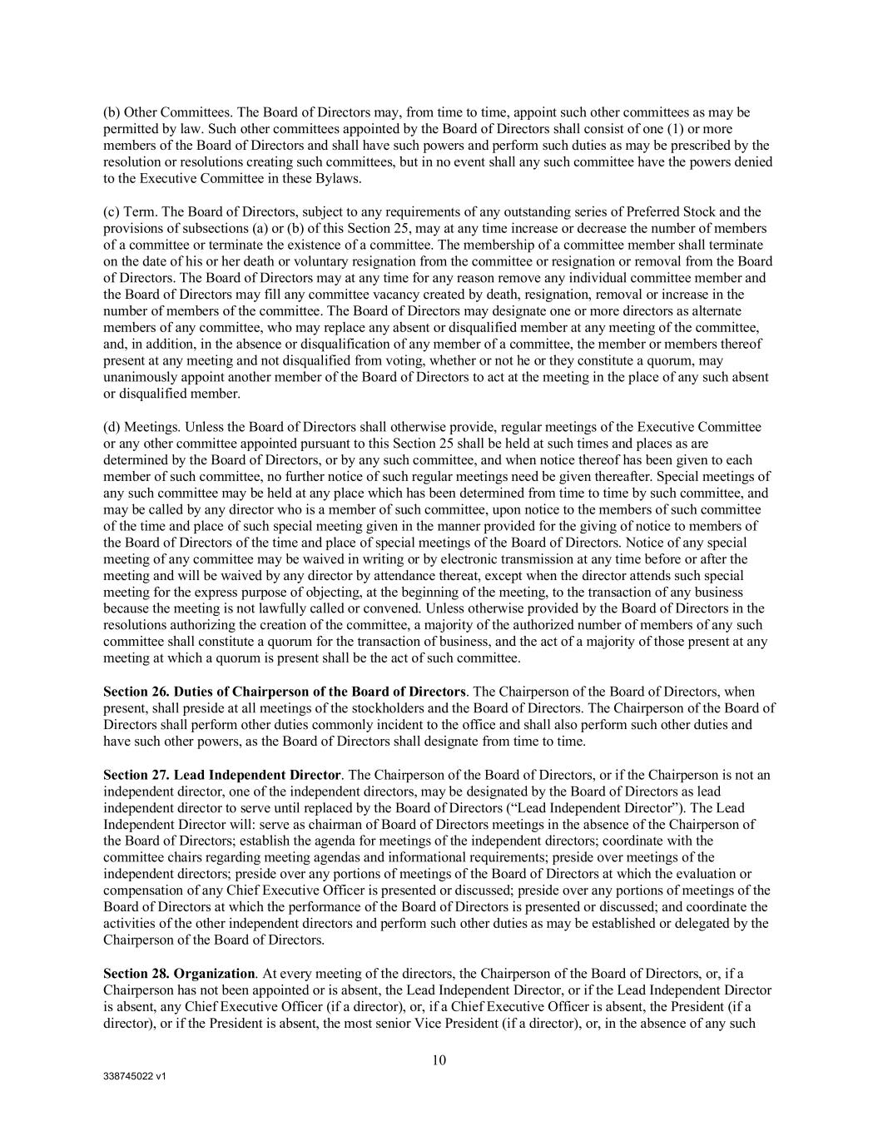
338745022 v1 10 (b) Other Committees. The Board of Directors may, from time to time, appoint such other committees as may be permitted by law. Such other committees appointed by the Board of Directors shall consist of one (1) or more members of the Board of Directors and shall have such powers and perform such duties as may be prescribed by the resolution or resolutions creating such committees, but in no event shall any such committee have the powers denied to the Executive Committee in these Bylaws. (c) Term. The Board of Directors, subject to any requirements of any outstanding series of Preferred Stock and the provisions of subsections (a) or (b) of this Section 25, may at any time increase or decrease the number of members of a committee or terminate the existence of a committee. The membership of a committee member shall terminate on the date of his or her death or voluntary resignation from the committee or resignation or removal from the Board of Directors. The Board of Directors may at any time for any reason remove any individual committee member and the Board of Directors may fill any committee vacancy created by death, resignation, removal or increase in the number of members of the committee. The Board of Directors may designate one or more directors as alternate members of any committee, who may replace any absent or disqualified member at any meeting of the committee, and, in addition, in the absence or disqualification of any member of a committee, the member or members thereof present at any meeting and not disqualified from voting, whether or not he or they constitute a quorum, may unanimously appoint another member of the Board of Directors to act at the meeting in the place of any such absent or disqualified member. (d) Meetings. Unless the Board of Directors shall otherwise provide, regular meetings of the Executive Committee or any other committee appointed pursuant to this Section 25 shall be held at such times and places as are determined by the Board of Directors, or by any such committee, and when notice thereof has been given to each member of such committee, no further notice of such regular meetings need be given thereafter. Special meetings of any such committee may be held at any place which has been determined from time to time by such committee, and may be called by any director who is a member of such committee, upon notice to the members of such committee of the time and place of such special meeting given in the manner provided for the giving of notice to members of the Board of Directors of the time and place of special meetings of the Board of Directors. Notice of any special meeting of any committee may be waived in writing or by electronic transmission at any time before or after the meeting and will be waived by any director by attendance thereat, except when the director attends such special meeting for the express purpose of objecting, at the beginning of the meeting, to the transaction of any business because the meeting is not lawfully called or convened. Unless otherwise provided by the Board of Directors in the resolutions authorizing the creation of the committee, a majority of the authorized number of members of any such committee shall constitute a quorum for the transaction of business, and the act of a majority of those present at any meeting at which a quorum is present shall be the act of such committee. Section 26. Duties of Chairperson of the Board of Directors. The Chairperson of the Board of Directors, when present, shall preside at all meetings of the stockholders and the Board of Directors. The Chairperson of the Board of Directors shall perform other duties commonly incident to the office and shall also perform such other duties and have such other powers, as the Board of Directors shall designate from time to time. Section 27. Lead Independent Director. The Chairperson of the Board of Directors, or if the Chairperson is not an independent director, one of the independent directors, may be designated by the Board of Directors as lead independent director to serve until replaced by the Board of Directors (“Lead Independent Director”). The Lead Independent Director will: serve as chairman of Board of Directors meetings in the absence of the Chairperson of the Board of Directors; establish the agenda for meetings of the independent directors; coordinate with the committee chairs regarding meeting agendas and informational requirements; preside over meetings of the independent directors; preside over any portions of meetings of the Board of Directors at which the evaluation or compensation of any Chief Executive Officer is presented or discussed; preside over any portions of meetings of the Board of Directors at which the performance of the Board of Directors is presented or discussed; and coordinate the activities of the other independent directors and perform such other duties as may be established or delegated by the Chairperson of the Board of Directors. Section 28. Organization. At every meeting of the directors, the Chairperson of the Board of Directors, or, if a Chairperson has not been appointed or is absent, the Lead Independent Director, or if the Lead Independent Director is absent, any Chief Executive Officer (if a director), or, if a Chief Executive Officer is absent, the President (if a director), or if the President is absent, the most senior Vice President (if a director), or, in the absence of any such

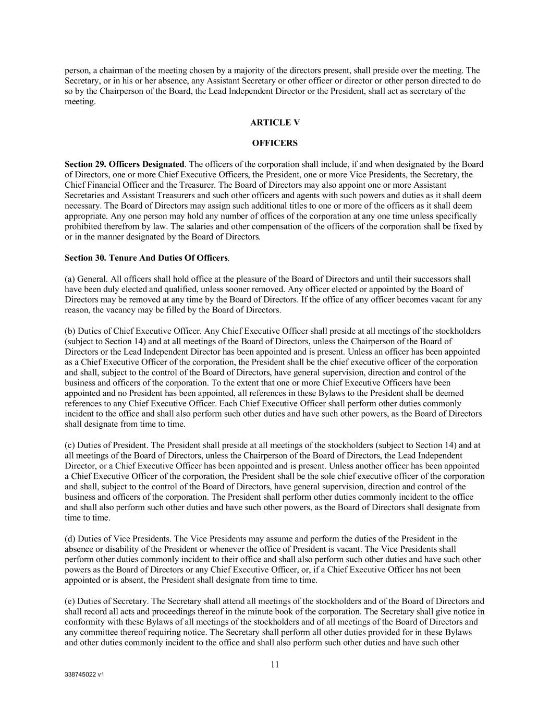
338745022 v1 11 person, a chairman of the meeting chosen by a majority of the directors present, shall preside over the meeting. The Secretary, or in his or her absence, any Assistant Secretary or other officer or director or other person directed to do so by the Chairperson of the Board, the Lead Independent Director or the President, shall act as secretary of the meeting. ARTICLE V OFFICERS Section 29. Officers Designated. The officers of the corporation shall include, if and when designated by the Board of Directors, one or more Chief Executive Officers, the President, one or more Vice Presidents, the Secretary, the Chief Financial Officer and the Treasurer. The Board of Directors may also appoint one or more Assistant Secretaries and Assistant Treasurers and such other officers and agents with such powers and duties as it shall deem necessary. The Board of Directors may assign such additional titles to one or more of the officers as it shall deem appropriate. Any one person may hold any number of offices of the corporation at any one time unless specifically prohibited therefrom by law. The salaries and other compensation of the officers of the corporation shall be fixed by or in the manner designated by the Board of Directors. Section 30. Tenure And Duties Of Officers. (a) General. All officers shall hold office at the pleasure of the Board of Directors and until their successors shall have been duly elected and qualified, unless sooner removed. Any officer elected or appointed by the Board of Directors may be removed at any time by the Board of Directors. If the office of any officer becomes vacant for any reason, the vacancy may be filled by the Board of Directors. (b) Duties of Chief Executive Officer. Any Chief Executive Officer shall preside at all meetings of the stockholders (subject to Section 14) and at all meetings of the Board of Directors, unless the Chairperson of the Board of Directors or the Lead Independent Director has been appointed and is present. Unless an officer has been appointed as a Chief Executive Officer of the corporation, the President shall be the chief executive officer of the corporation and shall, subject to the control of the Board of Directors, have general supervision, direction and control of the business and officers of the corporation. To the extent that one or more Chief Executive Officers have been appointed and no President has been appointed, all references in these Bylaws to the President shall be deemed references to any Chief Executive Officer. Each Chief Executive Officer shall perform other duties commonly incident to the office and shall also perform such other duties and have such other powers, as the Board of Directors shall designate from time to time. (c) Duties of President. The President shall preside at all meetings of the stockholders (subject to Section 14) and at all meetings of the Board of Directors, unless the Chairperson of the Board of Directors, the Lead Independent Director, or a Chief Executive Officer has been appointed and is present. Unless another officer has been appointed a Chief Executive Officer of the corporation, the President shall be the sole chief executive officer of the corporation and shall, subject to the control of the Board of Directors, have general supervision, direction and control of the business and officers of the corporation. The President shall perform other duties commonly incident to the office and shall also perform such other duties and have such other powers, as the Board of Directors shall designate from time to time. (d) Duties of Vice Presidents. The Vice Presidents may assume and perform the duties of the President in the absence or disability of the President or whenever the office of President is vacant. The Vice Presidents shall perform other duties commonly incident to their office and shall also perform such other duties and have such other powers as the Board of Directors or any Chief Executive Officer, or, if a Chief Executive Officer has not been appointed or is absent, the President shall designate from time to time. (e) Duties of Secretary. The Secretary shall attend all meetings of the stockholders and of the Board of Directors and shall record all acts and proceedings thereof in the minute book of the corporation. The Secretary shall give notice in conformity with these Bylaws of all meetings of the stockholders and of all meetings of the Board of Directors and any committee thereof requiring notice. The Secretary shall perform all other duties provided for in these Bylaws and other duties commonly incident to the office and shall also perform such other duties and have such other

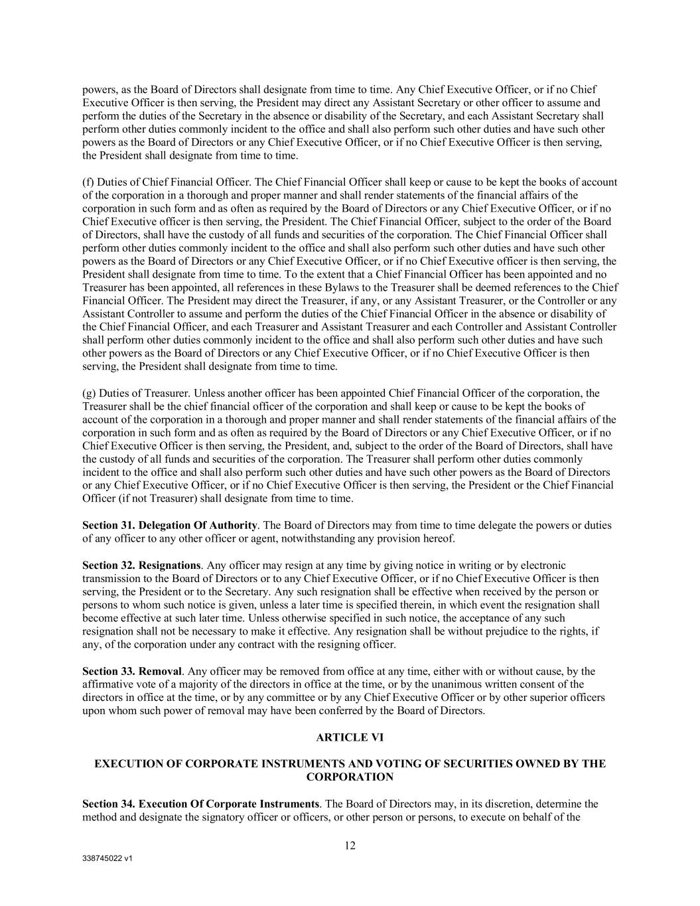
338745022 v1 12 powers, as the Board of Directors shall designate from time to time. Any Chief Executive Officer, or if no Chief Executive Officer is then serving, the President may direct any Assistant Secretary or other officer to assume and perform the duties of the Secretary in the absence or disability of the Secretary, and each Assistant Secretary shall perform other duties commonly incident to the office and shall also perform such other duties and have such other powers as the Board of Directors or any Chief Executive Officer, or if no Chief Executive Officer is then serving, the President shall designate from time to time. (f) Duties of Chief Financial Officer. The Chief Financial Officer shall keep or cause to be kept the books of account of the corporation in a thorough and proper manner and shall render statements of the financial affairs of the corporation in such form and as often as required by the Board of Directors or any Chief Executive Officer, or if no Chief Executive officer is then serving, the President. The Chief Financial Officer, subject to the order of the Board of Directors, shall have the custody of all funds and securities of the corporation. The Chief Financial Officer shall perform other duties commonly incident to the office and shall also perform such other duties and have such other powers as the Board of Directors or any Chief Executive Officer, or if no Chief Executive officer is then serving, the President shall designate from time to time. To the extent that a Chief Financial Officer has been appointed and no Treasurer has been appointed, all references in these Bylaws to the Treasurer shall be deemed references to the Chief Financial Officer. The President may direct the Treasurer, if any, or any Assistant Treasurer, or the Controller or any Assistant Controller to assume and perform the duties of the Chief Financial Officer in the absence or disability of the Chief Financial Officer, and each Treasurer and Assistant Treasurer and each Controller and Assistant Controller shall perform other duties commonly incident to the office and shall also perform such other duties and have such other powers as the Board of Directors or any Chief Executive Officer, or if no Chief Executive Officer is then serving, the President shall designate from time to time. (g) Duties of Treasurer. Unless another officer has been appointed Chief Financial Officer of the corporation, the Treasurer shall be the chief financial officer of the corporation and shall keep or cause to be kept the books of account of the corporation in a thorough and proper manner and shall render statements of the financial affairs of the corporation in such form and as often as required by the Board of Directors or any Chief Executive Officer, or if no Chief Executive Officer is then serving, the President, and, subject to the order of the Board of Directors, shall have the custody of all funds and securities of the corporation. The Treasurer shall perform other duties commonly incident to the office and shall also perform such other duties and have such other powers as the Board of Directors or any Chief Executive Officer, or if no Chief Executive Officer is then serving, the President or the Chief Financial Officer (if not Treasurer) shall designate from time to time. Section 31. Delegation Of Authority. The Board of Directors may from time to time delegate the powers or duties of any officer to any other officer or agent, notwithstanding any provision hereof. Section 32. Resignations. Any officer may resign at any time by giving notice in writing or by electronic transmission to the Board of Directors or to any Chief Executive Officer, or if no Chief Executive Officer is then serving, the President or to the Secretary. Any such resignation shall be effective when received by the person or persons to whom such notice is given, unless a later time is specified therein, in which event the resignation shall become effective at such later time. Unless otherwise specified in such notice, the acceptance of any such resignation shall not be necessary to make it effective. Any resignation shall be without prejudice to the rights, if any, of the corporation under any contract with the resigning officer. Section 33. Removal. Any officer may be removed from office at any time, either with or without cause, by the affirmative vote of a majority of the directors in office at the time, or by the unanimous written consent of the directors in office at the time, or by any committee or by any Chief Executive Officer or by other superior officers upon whom such power of removal may have been conferred by the Board of Directors. ARTICLE VI EXECUTION OF CORPORATE INSTRUMENTS AND VOTING OF SECURITIES OWNED BY THE CORPORATION Section 34. Execution Of Corporate Instruments. The Board of Directors may, in its discretion, determine the method and designate the signatory officer or officers, or other person or persons, to execute on behalf of the

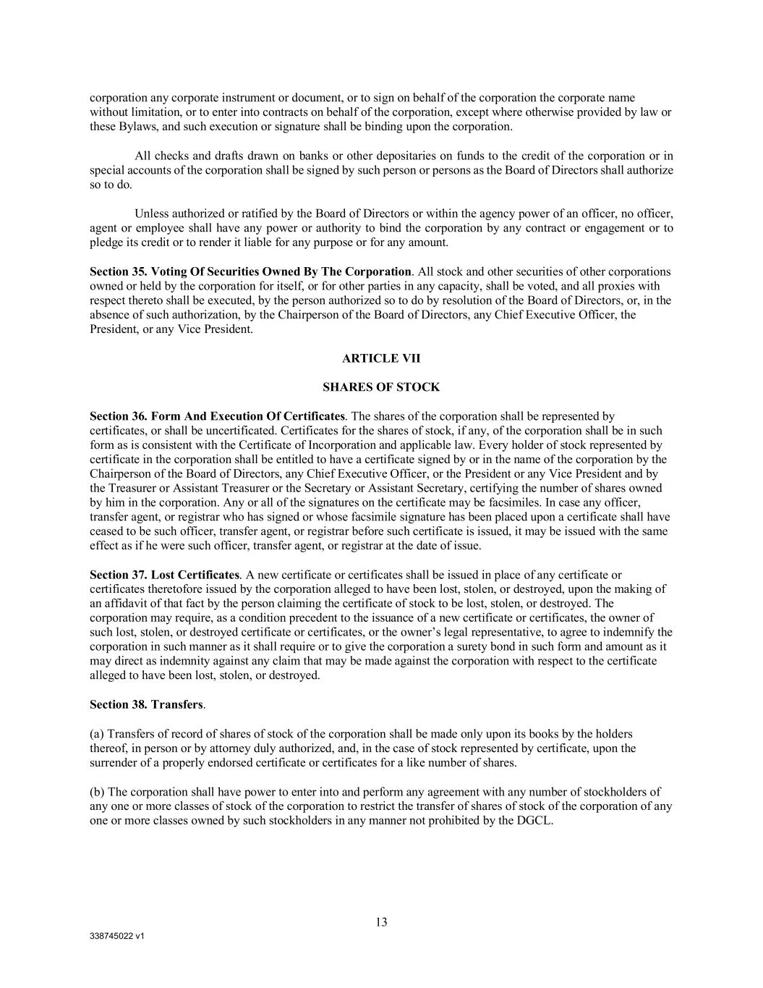
338745022 v1 13 corporation any corporate instrument or document, or to sign on behalf of the corporation the corporate name without limitation, or to enter into contracts on behalf of the corporation, except where otherwise provided by law or these Bylaws, and such execution or signature shall be binding upon the corporation. All checks and drafts drawn on banks or other depositaries on funds to the credit of the corporation or in special accounts of the corporation shall be signed by such person or persons as the Board of Directors shall authorize so to do. Unless authorized or ratified by the Board of Directors or within the agency power of an officer, no officer, agent or employee shall have any power or authority to bind the corporation by any contract or engagement or to pledge its credit or to render it liable for any purpose or for any amount. Section 35. Voting Of Securities Owned By The Corporation. All stock and other securities of other corporations owned or held by the corporation for itself, or for other parties in any capacity, shall be voted, and all proxies with respect thereto shall be executed, by the person authorized so to do by resolution of the Board of Directors, or, in the absence of such authorization, by the Chairperson of the Board of Directors, any Chief Executive Officer, the President, or any Vice President. ARTICLE VII SHARES OF STOCK Section 36. Form And Execution Of Certificates. The shares of the corporation shall be represented by certificates, or shall be uncertificated. Certificates for the shares of stock, if any, of the corporation shall be in such form as is consistent with the Certificate of Incorporation and applicable law. Every holder of stock represented by certificate in the corporation shall be entitled to have a certificate signed by or in the name of the corporation by the Chairperson of the Board of Directors, any Chief Executive Officer, or the President or any Vice President and by the Treasurer or Assistant Treasurer or the Secretary or Assistant Secretary, certifying the number of shares owned by him in the corporation. Any or all of the signatures on the certificate may be facsimiles. In case any officer, transfer agent, or registrar who has signed or whose facsimile signature has been placed upon a certificate shall have ceased to be such officer, transfer agent, or registrar before such certificate is issued, it may be issued with the same effect as if he were such officer, transfer agent, or registrar at the date of issue. Section 37. Lost Certificates. A new certificate or certificates shall be issued in place of any certificate or certificates theretofore issued by the corporation alleged to have been lost, stolen, or destroyed, upon the making of an affidavit of that fact by the person claiming the certificate of stock to be lost, stolen, or destroyed. The corporation may require, as a condition precedent to the issuance of a new certificate or certificates, the owner of such lost, stolen, or destroyed certificate or certificates, or the owner’s legal representative, to agree to indemnify the corporation in such manner as it shall require or to give the corporation a surety bond in such form and amount as it may direct as indemnity against any claim that may be made against the corporation with respect to the certificate alleged to have been lost, stolen, or destroyed. Section 38. Transfers. (a) Transfers of record of shares of stock of the corporation shall be made only upon its books by the holders thereof, in person or by attorney duly authorized, and, in the case of stock represented by certificate, upon the surrender of a properly endorsed certificate or certificates for a like number of shares. (b) The corporation shall have power to enter into and perform any agreement with any number of stockholders of any one or more classes of stock of the corporation to restrict the transfer of shares of stock of the corporation of any one or more classes owned by such stockholders in any manner not prohibited by the DGCL.

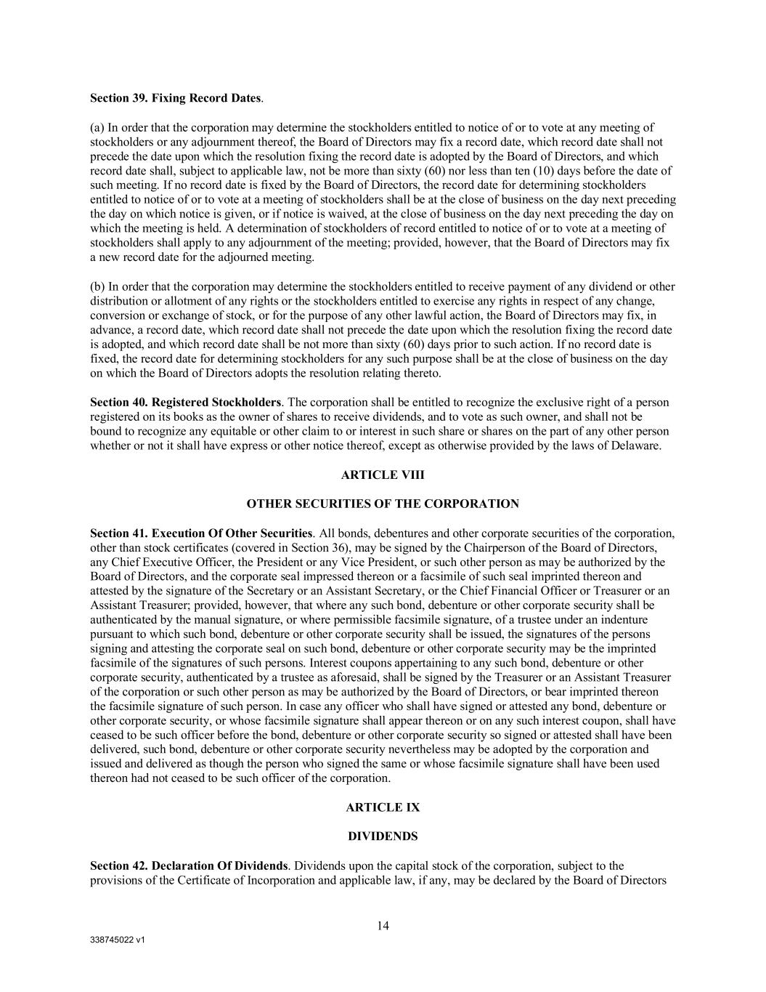
338745022 v1 14 Section 39. Fixing Record Dates. (a) In order that the corporation may determine the stockholders entitled to notice of or to vote at any meeting of stockholders or any adjournment thereof, the Board of Directors may fix a record date, which record date shall not precede the date upon which the resolution fixing the record date is adopted by the Board of Directors, and which record date shall, subject to applicable law, not be more than sixty (60) nor less than ten (10) days before the date of such meeting. If no record date is fixed by the Board of Directors, the record date for determining stockholders entitled to notice of or to vote at a meeting of stockholders shall be at the close of business on the day next preceding the day on which notice is given, or if notice is waived, at the close of business on the day next preceding the day on which the meeting is held. A determination of stockholders of record entitled to notice of or to vote at a meeting of stockholders shall apply to any adjournment of the meeting; provided, however, that the Board of Directors may fix a new record date for the adjourned meeting. (b) In order that the corporation may determine the stockholders entitled to receive payment of any dividend or other distribution or allotment of any rights or the stockholders entitled to exercise any rights in respect of any change, conversion or exchange of stock, or for the purpose of any other lawful action, the Board of Directors may fix, in advance, a record date, which record date shall not precede the date upon which the resolution fixing the record date is adopted, and which record date shall be not more than sixty (60) days prior to such action. If no record date is fixed, the record date for determining stockholders for any such purpose shall be at the close of business on the day on which the Board of Directors adopts the resolution relating thereto. Section 40. Registered Stockholders. The corporation shall be entitled to recognize the exclusive right of a person registered on its books as the owner of shares to receive dividends, and to vote as such owner, and shall not be bound to recognize any equitable or other claim to or interest in such share or shares on the part of any other person whether or not it shall have express or other notice thereof, except as otherwise provided by the laws of Delaware. ARTICLE VIII OTHER SECURITIES OF THE CORPORATION Section 41. Execution Of Other Securities. All bonds, debentures and other corporate securities of the corporation, other than stock certificates (covered in Section 36), may be signed by the Chairperson of the Board of Directors, any Chief Executive Officer, the President or any Vice President, or such other person as may be authorized by the Board of Directors, and the corporate seal impressed thereon or a facsimile of such seal imprinted thereon and attested by the signature of the Secretary or an Assistant Secretary, or the Chief Financial Officer or Treasurer or an Assistant Treasurer; provided, however, that where any such bond, debenture or other corporate security shall be authenticated by the manual signature, or where permissible facsimile signature, of a trustee under an indenture pursuant to which such bond, debenture or other corporate security shall be issued, the signatures of the persons signing and attesting the corporate seal on such bond, debenture or other corporate security may be the imprinted facsimile of the signatures of such persons. Interest coupons appertaining to any such bond, debenture or other corporate security, authenticated by a trustee as aforesaid, shall be signed by the Treasurer or an Assistant Treasurer of the corporation or such other person as may be authorized by the Board of Directors, or bear imprinted thereon the facsimile signature of such person. In case any officer who shall have signed or attested any bond, debenture or other corporate security, or whose facsimile signature shall appear thereon or on any such interest coupon, shall have ceased to be such officer before the bond, debenture or other corporate security so signed or attested shall have been delivered, such bond, debenture or other corporate security nevertheless may be adopted by the corporation and issued and delivered as though the person who signed the same or whose facsimile signature shall have been used thereon had not ceased to be such officer of the corporation. ARTICLE IX DIVIDENDS Section 42. Declaration Of Dividends. Dividends upon the capital stock of the corporation, subject to the provisions of the Certificate of Incorporation and applicable law, if any, may be declared by the Board of Directors

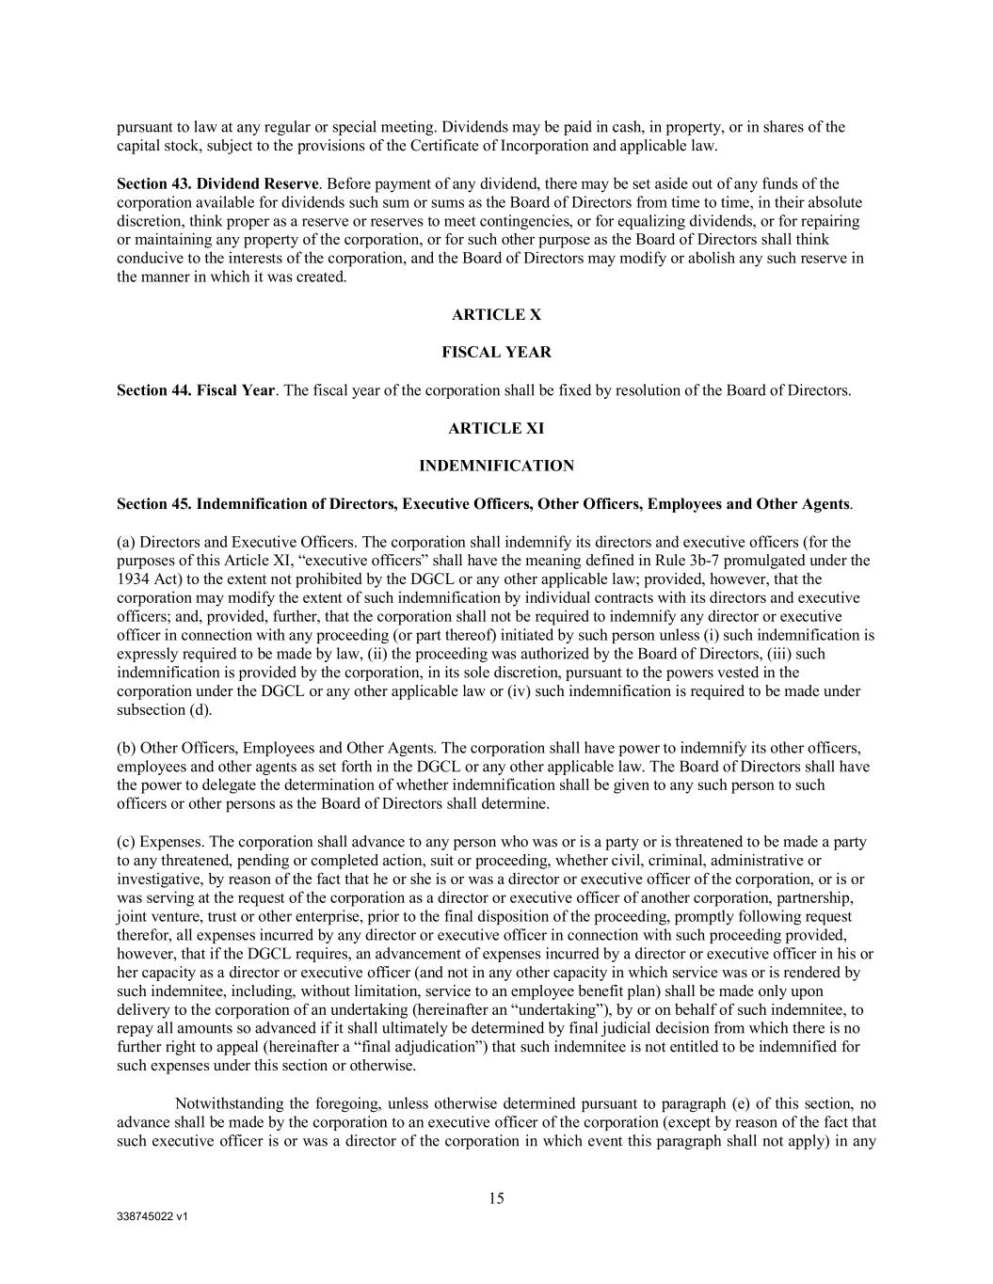
338745022 v1 15 pursuant to law at any regular or special meeting. Dividends may be paid in cash, in property, or in shares of the capital stock, subject to the provisions of the Certificate of Incorporation and applicable law. Section 43. Dividend Reserve. Before payment of any dividend, there may be set aside out of any funds of the corporation available for dividends such sum or sums as the Board of Directors from time to time, in their absolute discretion, think proper as a reserve or reserves to meet contingencies, or for equalizing dividends, or for repairing or maintaining any property of the corporation, or for such other purpose as the Board of Directors shall think conducive to the interests of the corporation, and the Board of Directors may modify or abolish any such reserve in the manner in which it was created. ARTICLE X FISCAL YEAR Section 44. Fiscal Year. The fiscal year of the corporation shall be fixed by resolution of the Board of Directors. ARTICLE XI INDEMNIFICATION Section 45. Indemnification of Directors, Executive Officers, Other Officers, Employees and Other Agents. (a) Directors and Executive Officers. The corporation shall indemnify its directors and executive officers (for the purposes of this Article XI, “executive officers” shall have the meaning defined in Rule 3b-7 promulgated under the 1934 Act) to the extent not prohibited by the DGCL or any other applicable law; provided, however, that the corporation may modify the extent of such indemnification by individual contracts with its directors and executive officers; and, provided, further, that the corporation shall not be required to indemnify any director or executive officer in connection with any proceeding (or part thereof) initiated by such person unless (i) such indemnification is expressly required to be made by law, (ii) the proceeding was authorized by the Board of Directors, (iii) such indemnification is provided by the corporation, in its sole discretion, pursuant to the powers vested in the corporation under the DGCL or any other applicable law or (iv) such indemnification is required to be made under subsection (d). (b) Other Officers, Employees and Other Agents. The corporation shall have power to indemnify its other officers, employees and other agents as set forth in the DGCL or any other applicable law. The Board of Directors shall have the power to delegate the determination of whether indemnification shall be given to any such person to such officers or other persons as the Board of Directors shall determine. (c) Expenses. The corporation shall advance to any person who was or is a party or is threatened to be made a party to any threatened, pending or completed action, suit or proceeding, whether civil, criminal, administrative or investigative, by reason of the fact that he or she is or was a director or executive officer of the corporation, or is or was serving at the request of the corporation as a director or executive officer of another corporation, partnership, joint venture, trust or other enterprise, prior to the final disposition of the proceeding, promptly following request therefor, all expenses incurred by any director or executive officer in connection with such proceeding provided, however, that if the DGCL requires, an advancement of expenses incurred by a director or executive officer in his or her capacity as a director or executive officer (and not in any other capacity in which service was or is rendered by such indemnitee, including, without limitation, service to an employee benefit plan) shall be made only upon delivery to the corporation of an undertaking (hereinafter an “undertaking”), by or on behalf of such indemnitee, to repay all amounts so advanced if it shall ultimately be determined by final judicial decision from which there is no further right to appeal (hereinafter a “final adjudication”) that such indemnitee is not entitled to be indemnified for such expenses under this section or otherwise. Notwithstanding the foregoing, unless otherwise determined pursuant to paragraph (e) of this section, no advance shall be made by the corporation to an executive officer of the corporation (except by reason of the fact that such executive officer is or was a director of the corporation in which event this paragraph shall not apply) in any

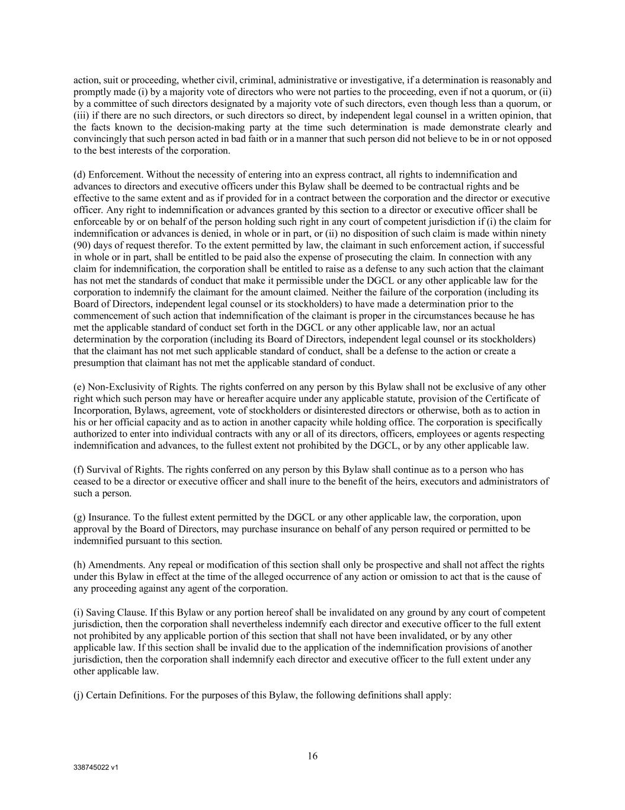
338745022 v1 16 action, suit or proceeding, whether civil, criminal, administrative or investigative, if a determination is reasonably and promptly made (i) by a majority vote of directors who were not parties to the proceeding, even if not a quorum, or (ii) by a committee of such directors designated by a majority vote of such directors, even though less than a quorum, or (iii) if there are no such directors, or such directors so direct, by independent legal counsel in a written opinion, that the facts known to the decision-making party at the time such determination is made demonstrate clearly and convincingly that such person acted in bad faith or in a manner that such person did not believe to be in or not opposed to the best interests of the corporation. (d) Enforcement. Without the necessity of entering into an express contract, all rights to indemnification and advances to directors and executive officers under this Bylaw shall be deemed to be contractual rights and be effective to the same extent and as if provided for in a contract between the corporation and the director or executive officer. Any right to indemnification or advances granted by this section to a director or executive officer shall be enforceable by or on behalf of the person holding such right in any court of competent jurisdiction if (i) the claim for indemnification or advances is denied, in whole or in part, or (ii) no disposition of such claim is made within ninety (90) days of request therefor. To the extent permitted by law, the claimant in such enforcement action, if successful in whole or in part, shall be entitled to be paid also the expense of prosecuting the claim. In connection with any claim for indemnification, the corporation shall be entitled to raise as a defense to any such action that the claimant has not met the standards of conduct that make it permissible under the DGCL or any other applicable law for the corporation to indemnify the claimant for the amount claimed. Neither the failure of the corporation (including its Board of Directors, independent legal counsel or its stockholders) to have made a determination prior to the commencement of such action that indemnification of the claimant is proper in the circumstances because he has met the applicable standard of conduct set forth in the DGCL or any other applicable law, nor an actual determination by the corporation (including its Board of Directors, independent legal counsel or its stockholders) that the claimant has not met such applicable standard of conduct, shall be a defense to the action or create a presumption that claimant has not met the applicable standard of conduct. (e) Non-Exclusivity of Rights. The rights conferred on any person by this Bylaw shall not be exclusive of any other right which such person may have or hereafter acquire under any applicable statute, provision of the Certificate of Incorporation, Bylaws, agreement, vote of stockholders or disinterested directors or otherwise, both as to action in his or her official capacity and as to action in another capacity while holding office. The corporation is specifically authorized to enter into individual contracts with any or all of its directors, officers, employees or agents respecting indemnification and advances, to the fullest extent not prohibited by the DGCL, or by any other applicable law. (f) Survival of Rights. The rights conferred on any person by this Bylaw shall continue as to a person who has ceased to be a director or executive officer and shall inure to the benefit of the heirs, executors and administrators of such a person. (g) Insurance. To the fullest extent permitted by the DGCL or any other applicable law, the corporation, upon approval by the Board of Directors, may purchase insurance on behalf of any person required or permitted to be indemnified pursuant to this section. (h) Amendments. Any repeal or modification of this section shall only be prospective and shall not affect the rights under this Bylaw in effect at the time of the alleged occurrence of any action or omission to act that is the cause of any proceeding against any agent of the corporation. (i) Saving Clause. If this Bylaw or any portion hereof shall be invalidated on any ground by any court of competent jurisdiction, then the corporation shall nevertheless indemnify each director and executive officer to the full extent not prohibited by any applicable portion of this section that shall not have been invalidated, or by any other applicable law. If this section shall be invalid due to the application of the indemnification provisions of another jurisdiction, then the corporation shall indemnify each director and executive officer to the full extent under any other applicable law. (j) Certain Definitions. For the purposes of this Bylaw, the following definitions shall apply:

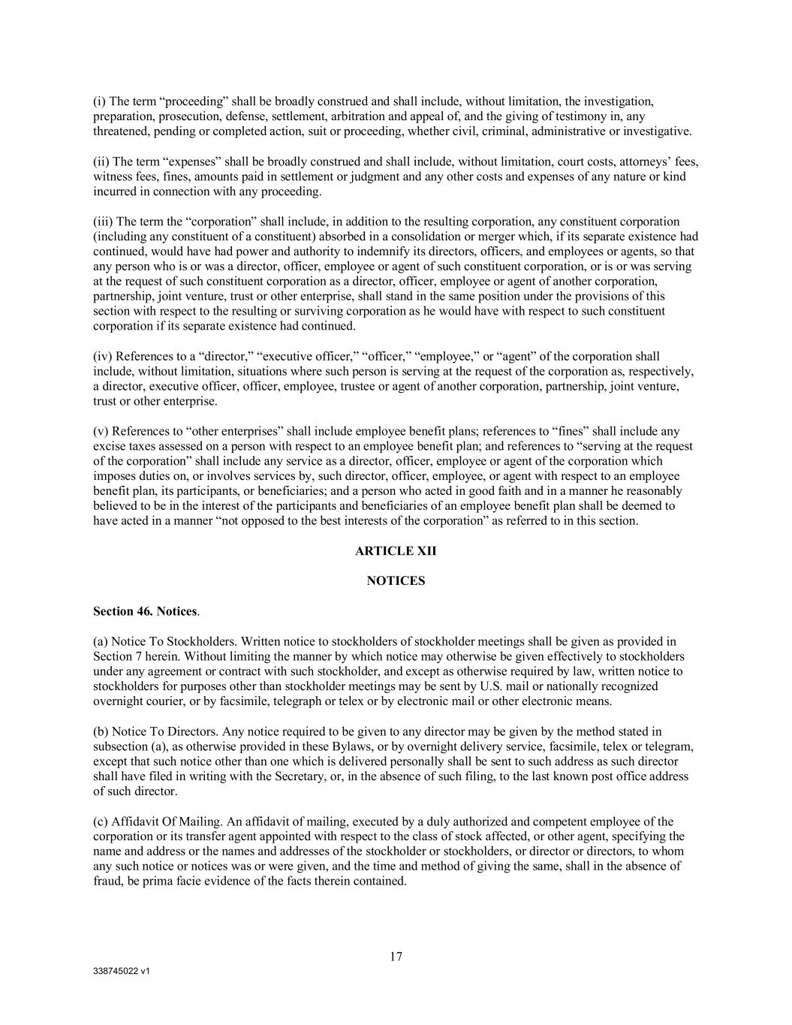
338745022 v1 17 (i) The term “proceeding” shall be broadly construed and shall include, without limitation, the investigation, preparation, prosecution, defense, settlement, arbitration and appeal of, and the giving of testimony in, any threatened, pending or completed action, suit or proceeding, whether civil, criminal, administrative or investigative. (ii) The term “expenses” shall be broadly construed and shall include, without limitation, court costs, attorneys’ fees, witness fees, fines, amounts paid in settlement or judgment and any other costs and expenses of any nature or kind incurred in connection with any proceeding. (iii) The term the “corporation” shall include, in addition to the resulting corporation, any constituent corporation (including any constituent of a constituent) absorbed in a consolidation or merger which, if its separate existence had continued, would have had power and authority to indemnify its directors, officers, and employees or agents, so that any person who is or was a director, officer, employee or agent of such constituent corporation, or is or was serving at the request of such constituent corporation as a director, officer, employee or agent of another corporation, partnership, joint venture, trust or other enterprise, shall stand in the same position under the provisions of this section with respect to the resulting or surviving corporation as he would have with respect to such constituent corporation if its separate existence had continued. (iv) References to a “director,” “executive officer,” “officer,” “employee,” or “agent” of the corporation shall include, without limitation, situations where such person is serving at the request of the corporation as, respectively, a director, executive officer, officer, employee, trustee or agent of another corporation, partnership, joint venture, trust or other enterprise. (v) References to “other enterprises” shall include employee benefit plans; references to “fines” shall include any excise taxes assessed on a person with respect to an employee benefit plan; and references to “serving at the request of the corporation” shall include any service as a director, officer, employee or agent of the corporation which imposes duties on, or involves services by, such director, officer, employee, or agent with respect to an employee benefit plan, its participants, or beneficiaries; and a person who acted in good faith and in a manner he reasonably believed to be in the interest of the participants and beneficiaries of an employee benefit plan shall be deemed to have acted in a manner “not opposed to the best interests of the corporation” as referred to in this section. ARTICLE XII NOTICES Section 46. Notices. (a) Notice To Stockholders. Written notice to stockholders of stockholder meetings shall be given as provided in Section 7 herein. Without limiting the manner by which notice may otherwise be given effectively to stockholders under any agreement or contract with such stockholder, and except as otherwise required by law, written notice to stockholders for purposes other than stockholder meetings may be sent by U.S. mail or nationally recognized overnight courier, or by facsimile, telegraph or telex or by electronic mail or other electronic means. (b) Notice To Directors. Any notice required to be given to any director may be given by the method stated in subsection (a), as otherwise provided in these Bylaws, or by overnight delivery service, facsimile, telex or telegram, except that such notice other than one which is delivered personally shall be sent to such address as such director shall have filed in writing with the Secretary, or, in the absence of such filing, to the last known post office address of such director. (c) Affidavit Of Mailing. An affidavit of mailing, executed by a duly authorized and competent employee of the corporation or its transfer agent appointed with respect to the class of stock affected, or other agent, specifying the name and address or the names and addresses of the stockholder or stockholders, or director or directors, to whom any such notice or notices was or were given, and the time and method of giving the same, shall in the absence of fraud, be prima facie evidence of the facts therein contained.

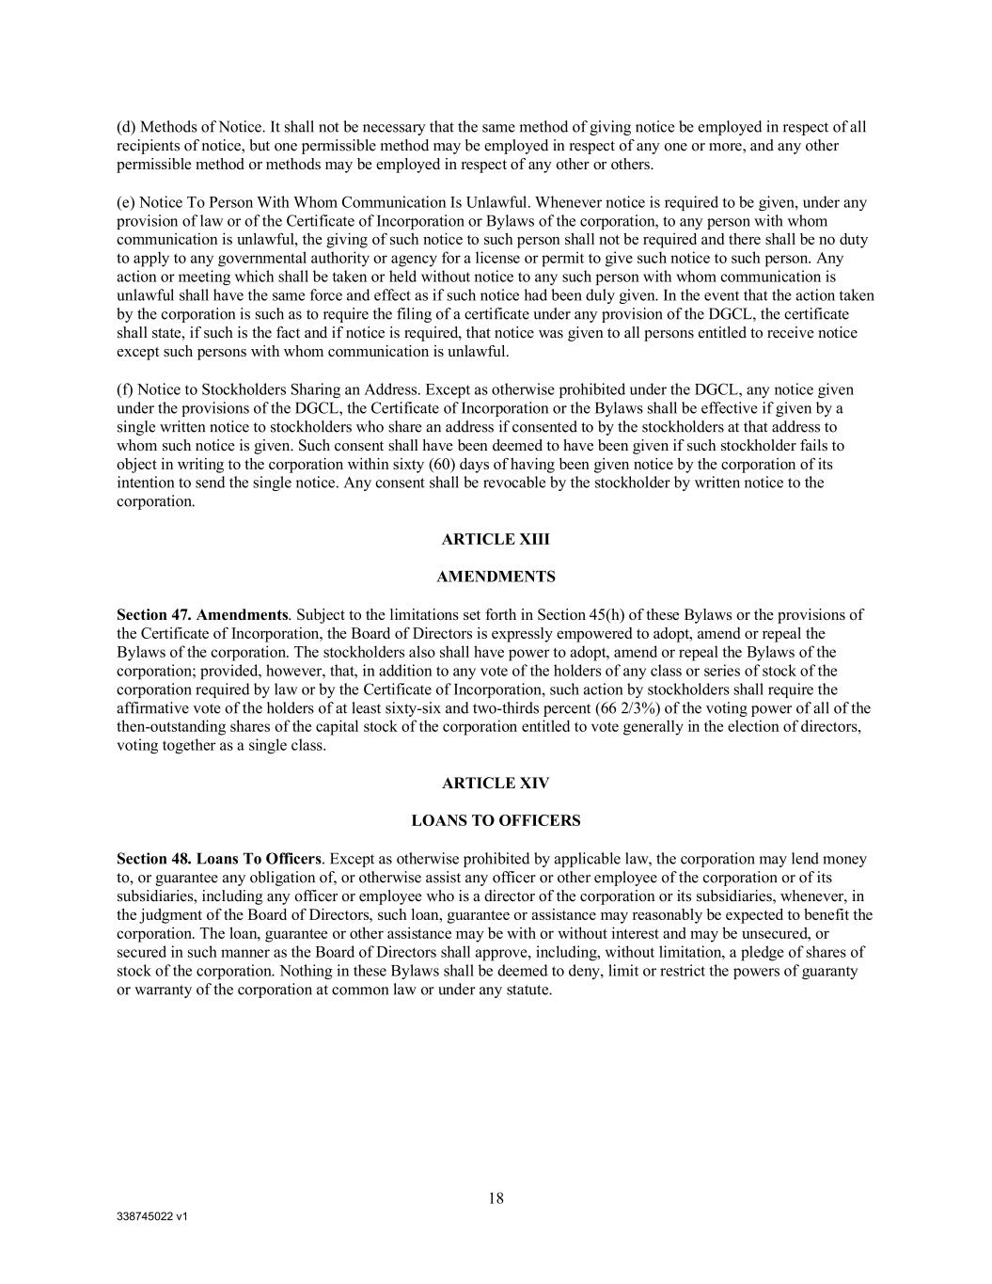
338745022 v1 18 (d) Methods of Notice. It shall not be necessary that the same method of giving notice be employed in respect of all recipients of notice, but one permissible method may be employed in respect of any one or more, and any other permissible method or methods may be employed in respect of any other or others. (e) Notice To Person With Whom Communication Is Unlawful. Whenever notice is required to be given, under any provision of law or of the Certificate of Incorporation or Bylaws of the corporation, to any person with whom communication is unlawful, the giving of such notice to such person shall not be required and there shall be no duty to apply to any governmental authority or agency for a license or permit to give such notice to such person. Any action or meeting which shall be taken or held without notice to any such person with whom communication is unlawful shall have the same force and effect as if such notice had been duly given. In the event that the action taken by the corporation is such as to require the filing of a certificate under any provision of the DGCL, the certificate shall state, if such is the fact and if notice is required, that notice was given to all persons entitled to receive notice except such persons with whom communication is unlawful. (f) Notice to Stockholders Sharing an Address. Except as otherwise prohibited under the DGCL, any notice given under the provisions of the DGCL, the Certificate of Incorporation or the Bylaws shall be effective if given by a single written notice to stockholders who share an address if consented to by the stockholders at that address to whom such notice is given. Such consent shall have been deemed to have been given if such stockholder fails to object in writing to the corporation within sixty (60) days of having been given notice by the corporation of its intention to send the single notice. Any consent shall be revocable by the stockholder by written notice to the corporation. ARTICLE XIII AMENDMENTS Section 47. Amendments. Subject to the limitations set forth in Section 45(h) of these Bylaws or the provisions of the Certificate of Incorporation, the Board of Directors is expressly empowered to adopt, amend or repeal the Bylaws of the corporation. The stockholders also shall have power to adopt, amend or repeal the Bylaws of the corporation; provided, however, that, in addition to any vote of the holders of any class or series of stock of the corporation required by law or by the Certificate of Incorporation, such action by stockholders shall require the affirmative vote of the holders of at least sixty-six and two-thirds percent (66 2/3%) of the voting power of all of the then-outstanding shares of the capital stock of the corporation entitled to vote generally in the election of directors, voting together as a single class. ARTICLE XIV LOANS TO OFFICERS Section 48. Loans To Officers. Except as otherwise prohibited by applicable law, the corporation may lend money to, or guarantee any obligation of, or otherwise assist any officer or other employee of the corporation or of its subsidiaries, including any officer or employee who is a director of the corporation or its subsidiaries, whenever, in the judgment of the Board of Directors, such loan, guarantee or assistance may reasonably be expected to benefit the corporation. The loan, guarantee or other assistance may be with or without interest and may be unsecured, or secured in such manner as the Board of Directors shall approve, including, without limitation, a pledge of shares of stock of the corporation. Nothing in these Bylaws shall be deemed to deny, limit or restrict the powers of guaranty or warranty of the corporation at common law or under any statute.

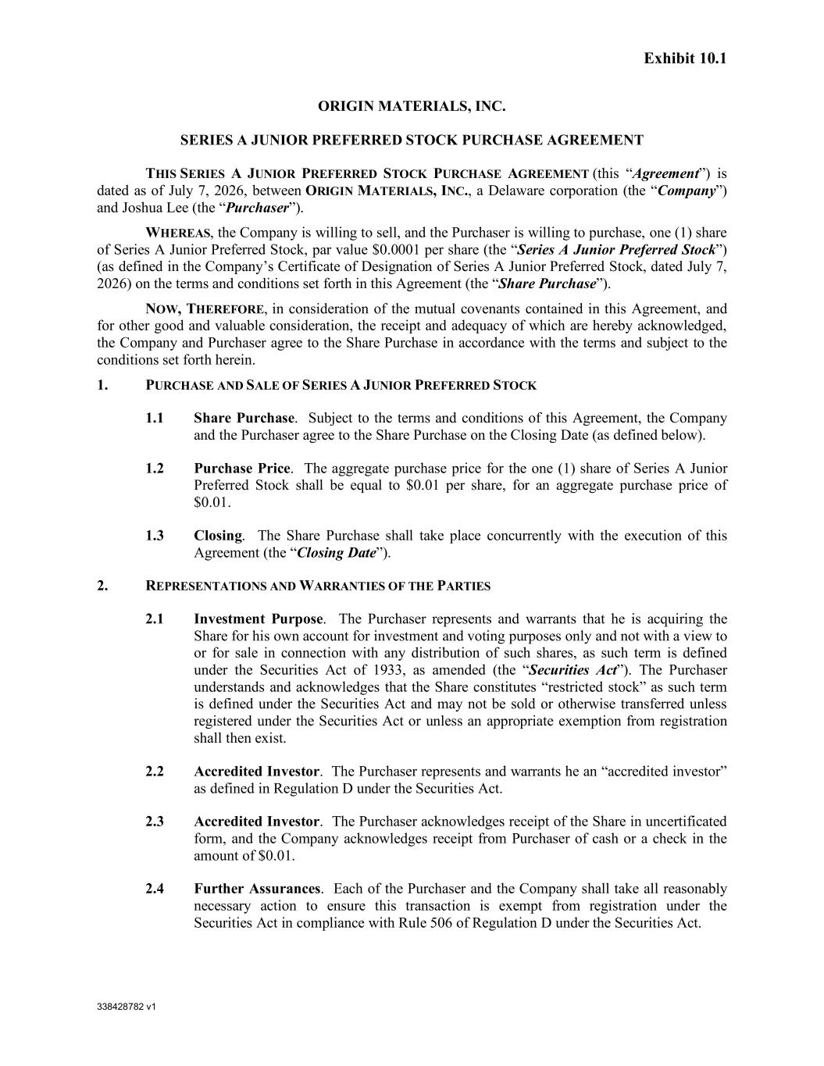
338428782 v1 Exhibit 10.1 ORIGIN MATERIALS, INC. SERIES A JUNIOR PREFERRED STOCK PURCHASE AGREEMENT THIS SERIES A JUNIOR PREFERRED STOCK PURCHASE AGREEMENT (this “Agreement”) is dated as of July 7, 2026, between ORIGIN MATERIALS, INC., a Delaware corporation (the “Company”) and Joshua Lee (the “Purchaser”). WHEREAS, the Company is willing to sell, and the Purchaser is willing to purchase, one (1) share of Series A Junior Preferred Stock, par value $0.0001 per share (the “Series A Junior Preferred Stock”) (as defined in the Company’s Certificate of Designation of Series A Junior Preferred Stock, dated July 7, 2026) on the terms and conditions set forth in this Agreement (the “Share Purchase”). NOW, THEREFORE, in consideration of the mutual covenants contained in this Agreement, and for other good and valuable consideration, the receipt and adequacy of which are hereby acknowledged, the Company and Purchaser agree to the Share Purchase in accordance with the terms and subject to the conditions set forth herein. 1. PURCHASE AND SALE OF SERIES A JUNIOR PREFERRED STOCK 1.1 Share Purchase. Subject to the terms and conditions of this Agreement, the Company and the Purchaser agree to the Share Purchase on the Closing Date (as defined below). 1.2 Purchase Price. The aggregate purchase price for the one (1) share of Series A Junior Preferred Stock shall be equal to $0.01 per share, for an aggregate purchase price of $0.01. 1.3 Closing. The Share Purchase shall take place concurrently with the execution of this Agreement (the “Closing Date”). 2. REPRESENTATIONS AND WARRANTIES OF THE PARTIES 2.1 Investment Purpose. The Purchaser represents and warrants that he is acquiring the Share for his own account for investment and voting purposes only and not with a view to or for sale in connection with any distribution of such shares, as such term is defined under the Securities Act of 1933, as amended (the “Securities Act”). The Purchaser understands and acknowledges that the Share constitutes “restricted stock” as such term is defined under the Securities Act and may not be sold or otherwise transferred unless registered under the Securities Act or unless an appropriate exemption from registration shall then exist. 2.2 Accredited Investor. The Purchaser represents and warrants he an “accredited investor” as defined in Regulation D under the Securities Act. 2.3 Accredited Investor. The Purchaser acknowledges receipt of the Share in uncertificated form, and the Company acknowledges receipt from Purchaser of cash or a check in the amount of $0.01. 2.4 Further Assurances. Each of the Purchaser and the Company shall take all reasonably necessary action to ensure this transaction is exempt from registration under the Securities Act in compliance with Rule 506 of Regulation D under the Securities Act.

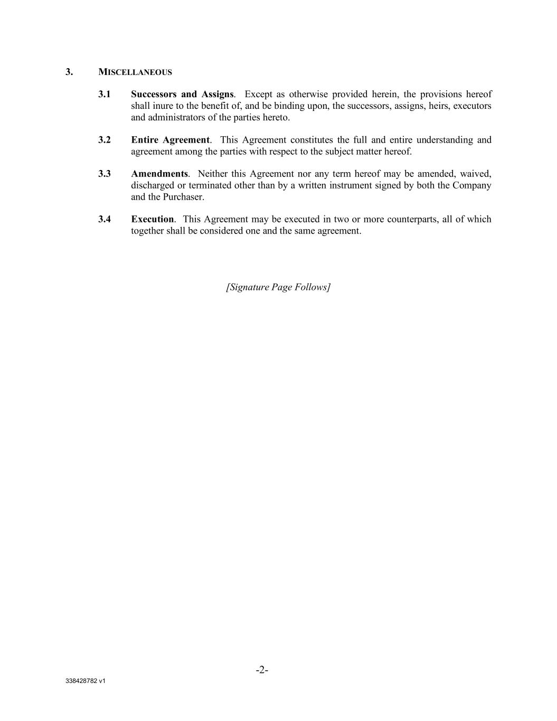
338428782 v1 -2- 3. MISCELLANEOUS 3.1 Successors and Assigns. Except as otherwise provided herein, the provisions hereof shall inure to the benefit of, and be binding upon, the successors, assigns, heirs, executors and administrators of the parties hereto. 3.2 Entire Agreement. This Agreement constitutes the full and entire understanding and agreement among the parties with respect to the subject matter hereof. 3.3 Amendments. Neither this Agreement nor any term hereof may be amended, waived, discharged or terminated other than by a written instrument signed by both the Company and the Purchaser. 3.4 Execution. This Agreement may be executed in two or more counterparts, all of which together shall be considered one and the same agreement. [Signature Page Follows]

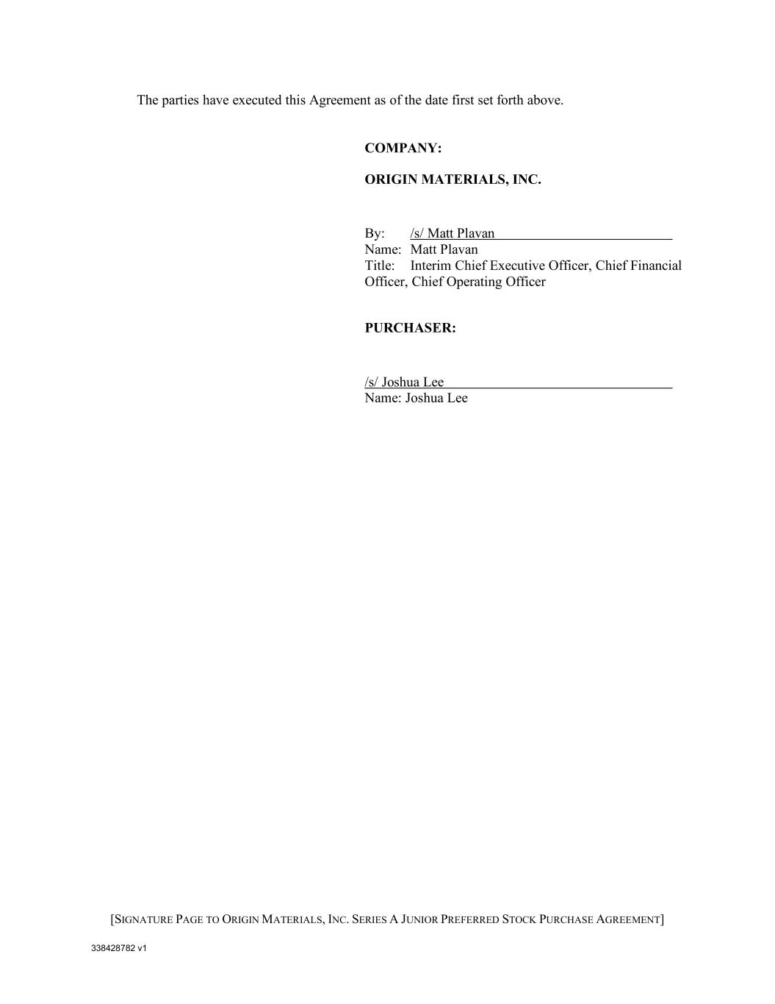
338428782 v1 [SIGNATURE PAGE TO ORIGIN MATERIALS, INC. SERIES A JUNIOR PREFERRED STOCK PURCHASE AGREEMENT] The parties have executed this Agreement as of the date first set forth above. COMPANY: ORIGIN MATERIALS, INC. By: /s/ Matt Plavan Name: Matt Plavan Title: Interim Chief Executive Officer, Chief Financial Officer, Chief Operating Officer PURCHASER: /s/ Joshua Lee Name: Joshua Lee

